# (34) Vegetation

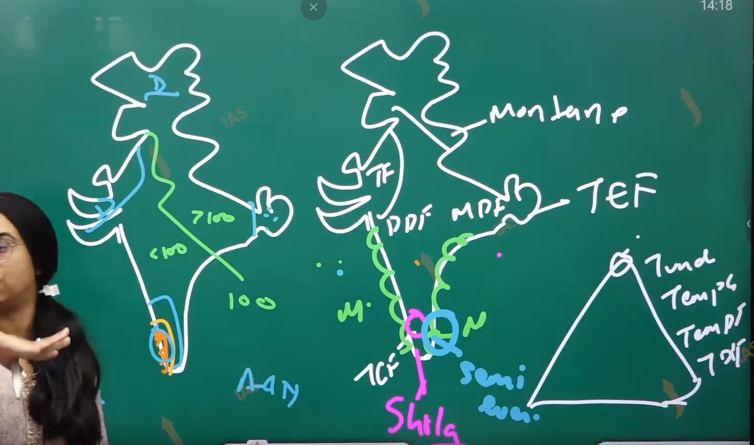

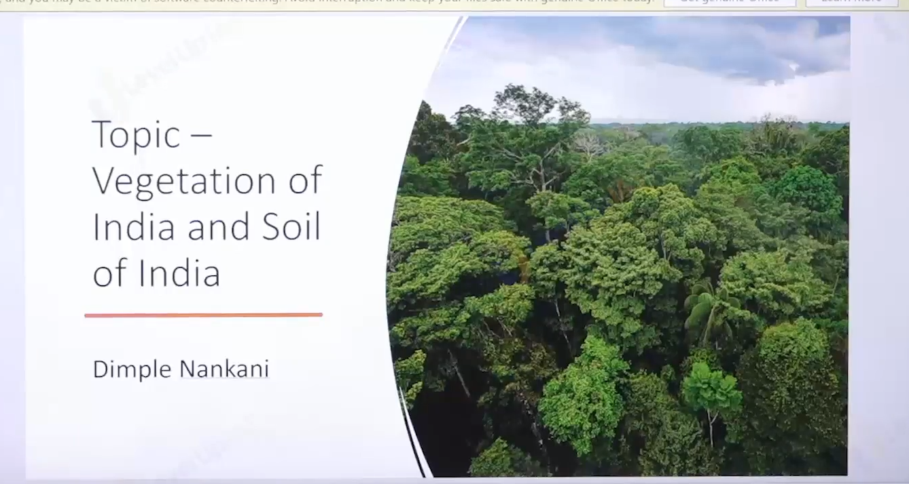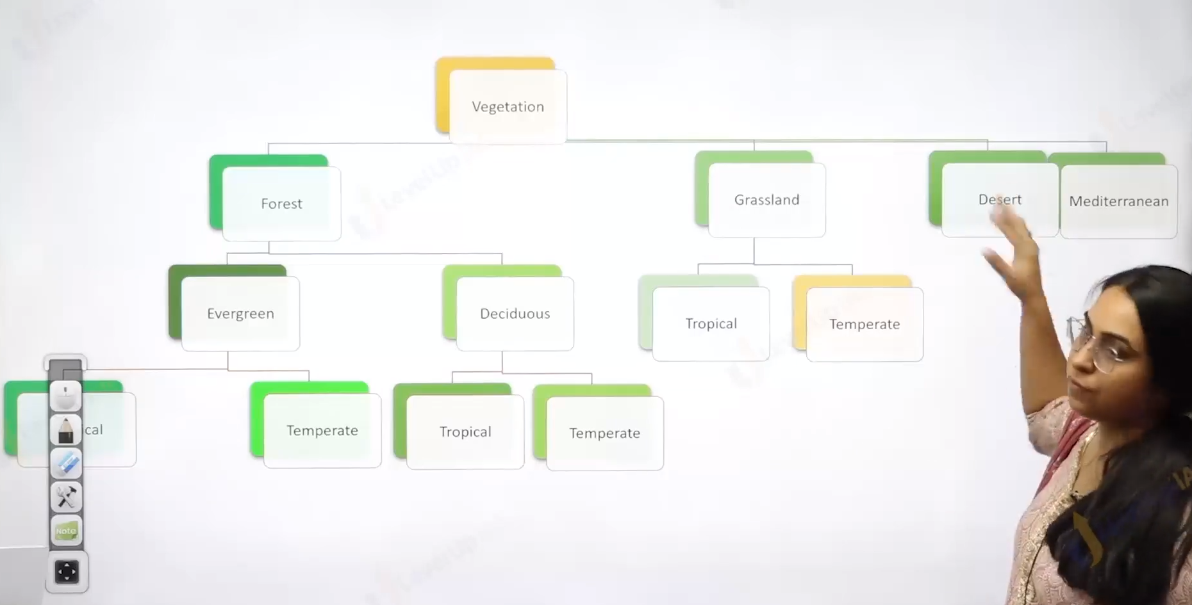

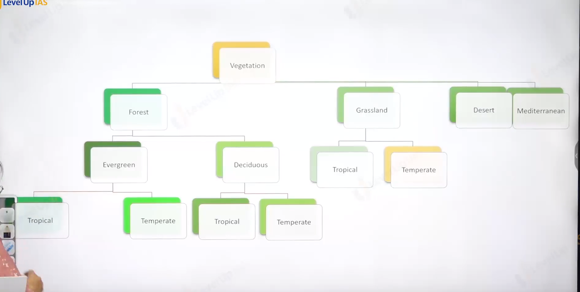

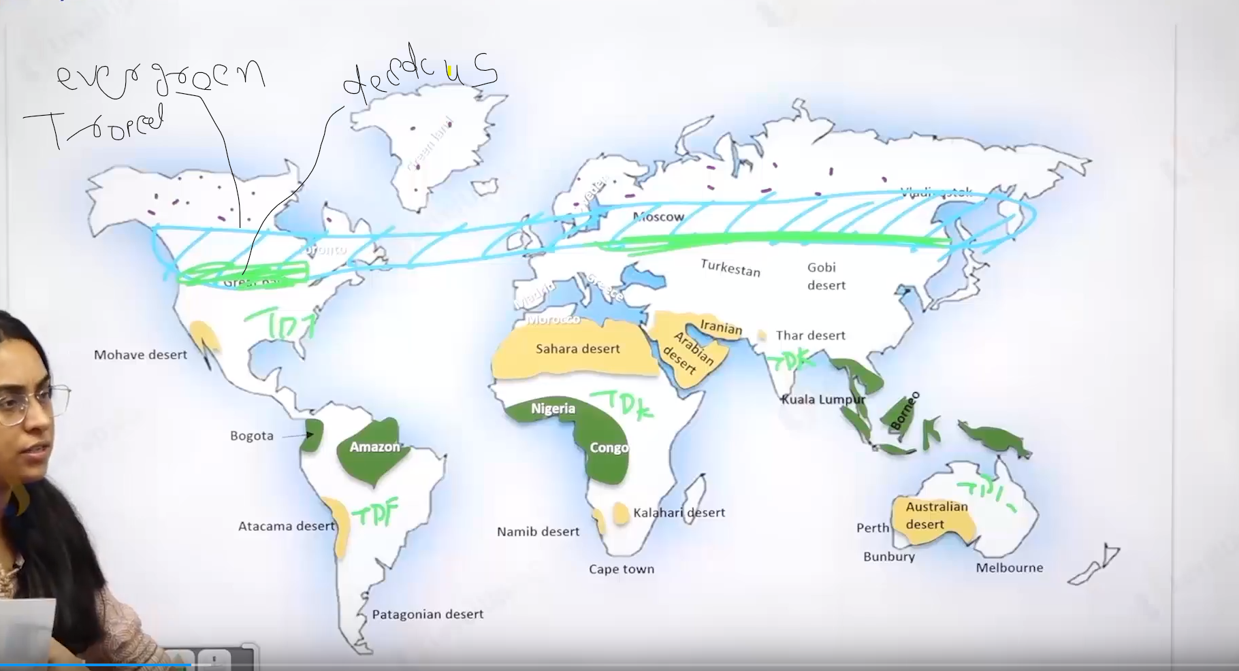

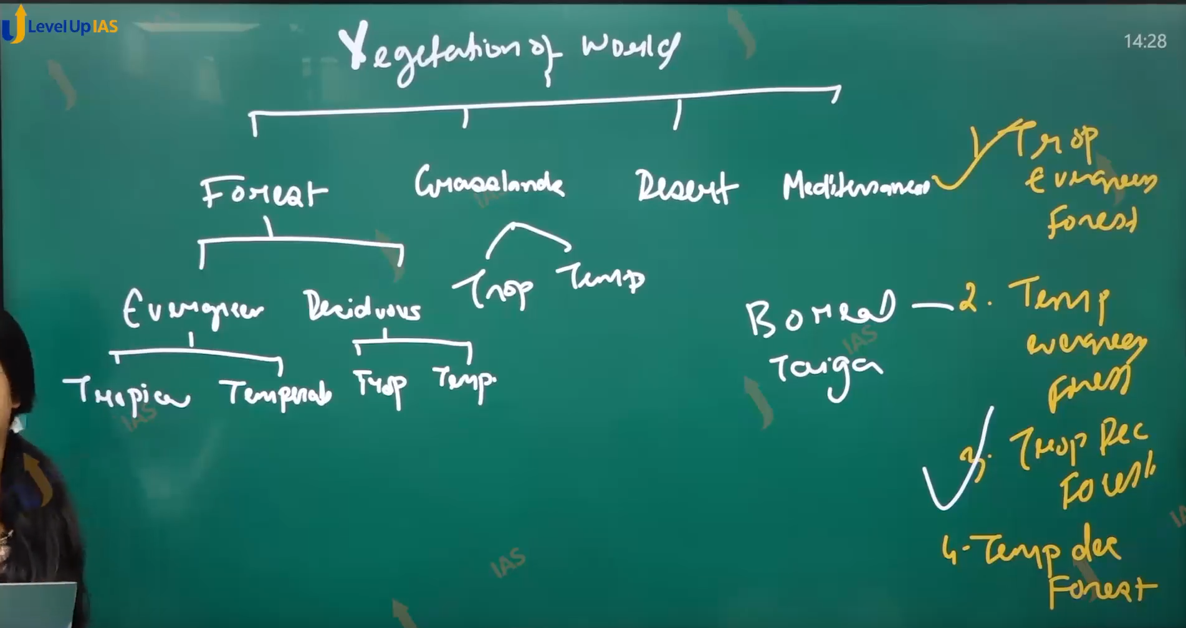

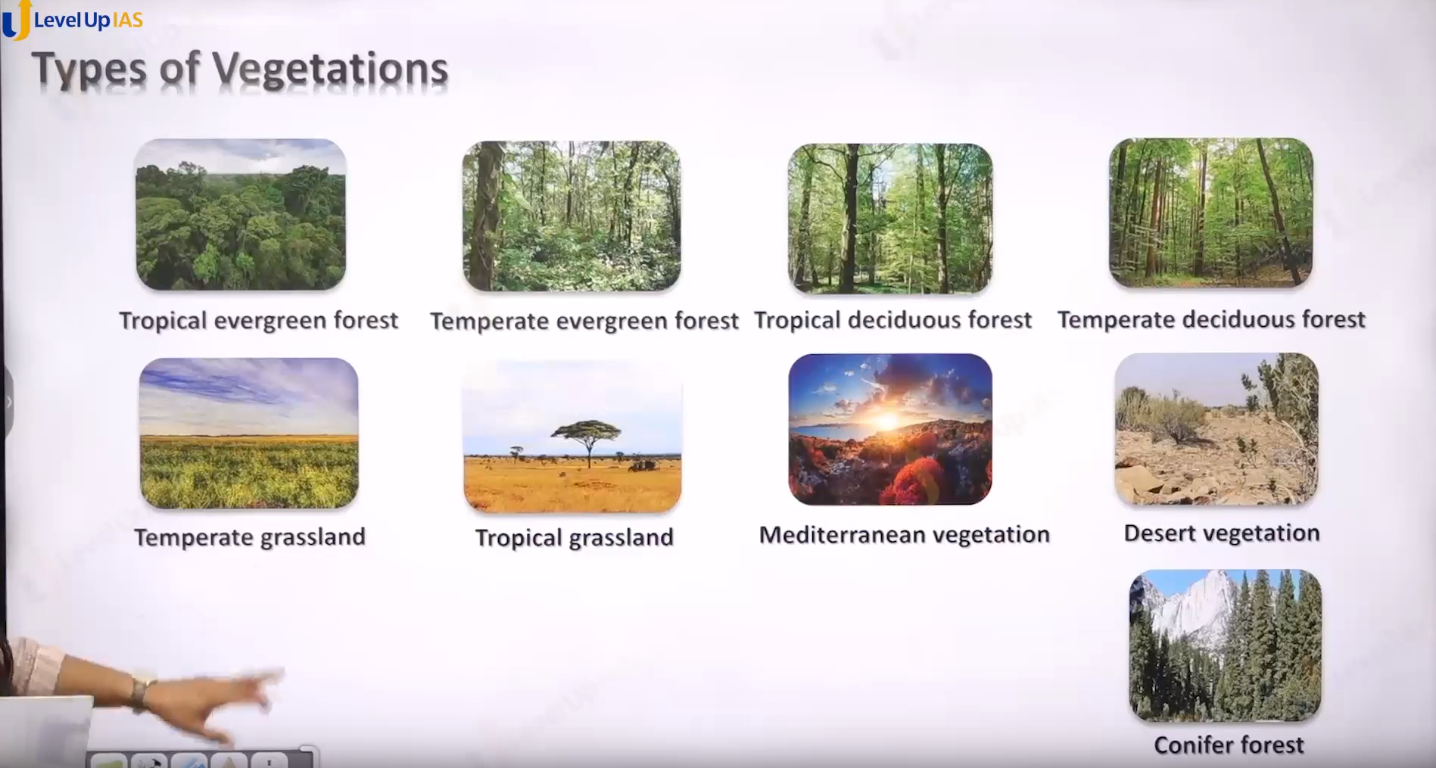

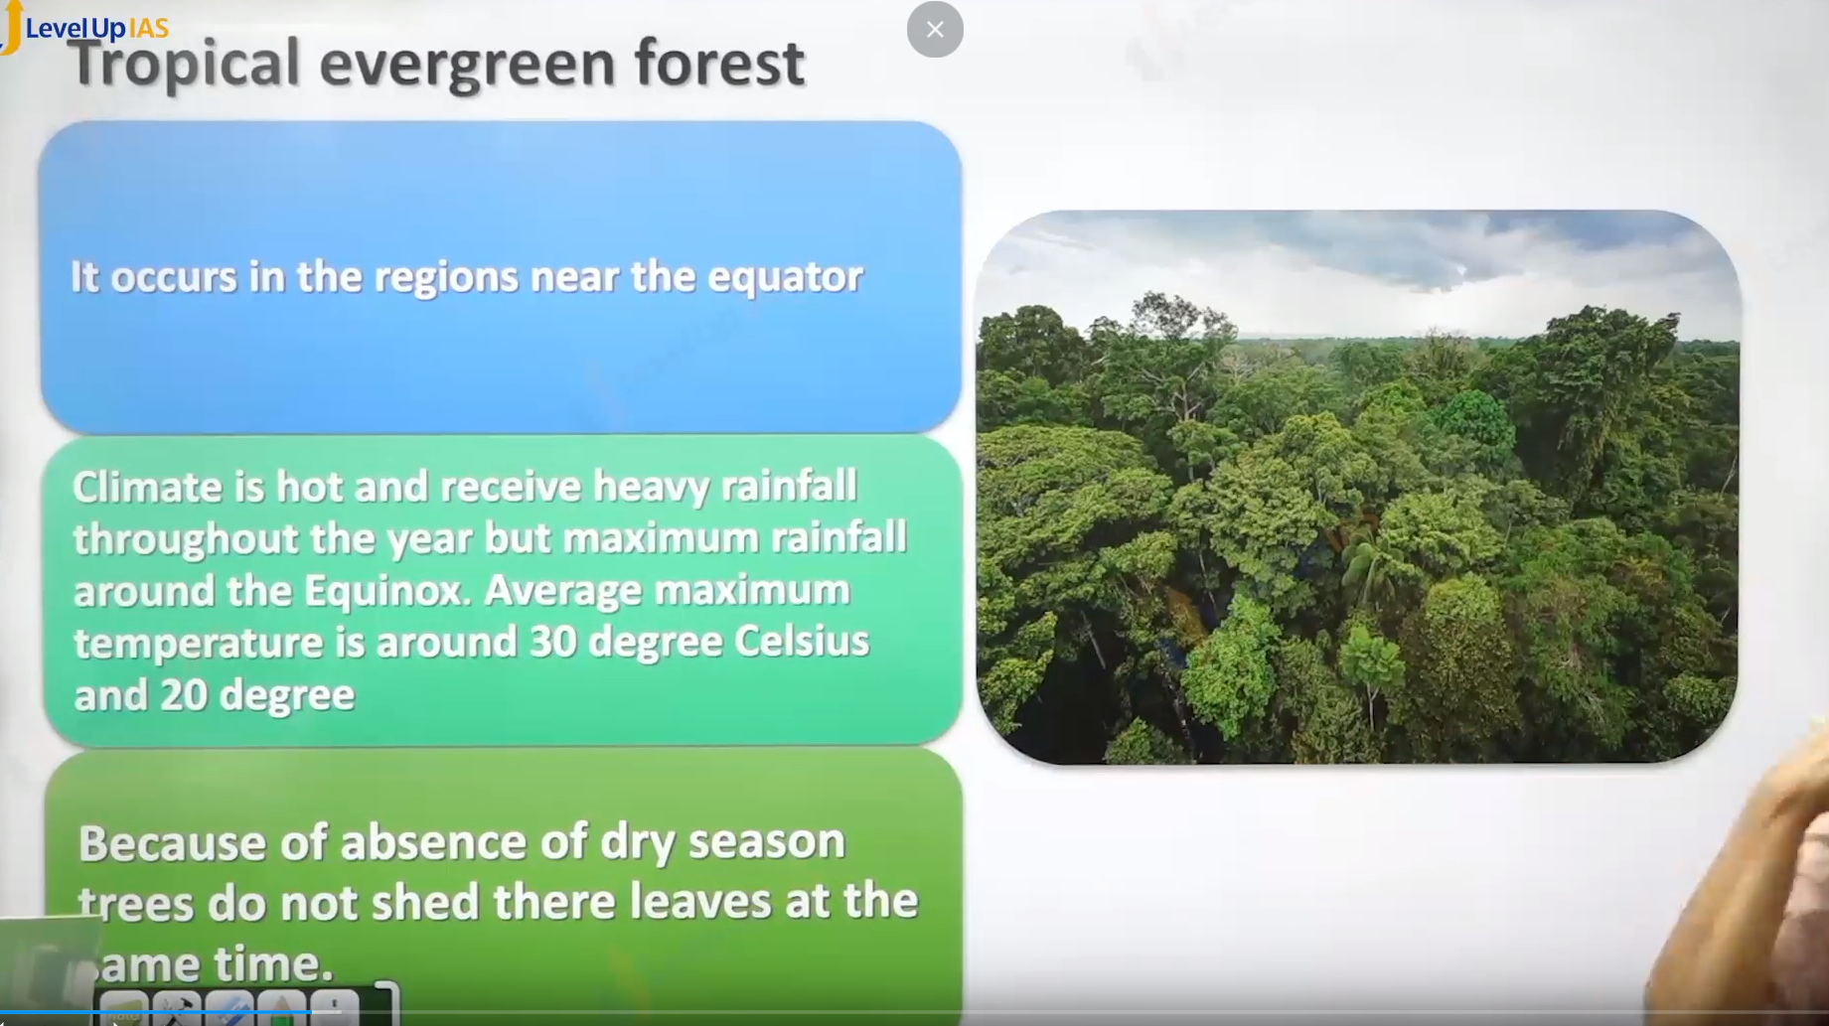

Tropical evergreen forest:

1. It occurs that the region near the equator climate is hot and therefore it receives heavy rainfall throughout the year. But maximum rainfall occurred around the equinox.
2. There is absence of dray season therefore trees do not shade their leaves at same time in the season.
3. The Season of place can be described as each day the same more or less Morning is clear and bright and by afternoon sun climbs up in the sky heating the region forming dark cloud. Leading to rainfall and lightning.
4. It seen in the India Andaman and Nicobar Islands Lakshadweep and southwest side of western ghat, and northeast regions.
5. The soil of tropical evergreen forest is not fertile. As the nutrients are leached down by the rainwater which are then acquired by the plants
6. And soil does not have the major nutrients.
7. This tropical ever green forest once cut cannot be received back.
8. Ex. cutting in Southeast Asia for palm cultivation, cutting in amazon in Brazil for coffee plantations, cutting in Congo forest, for cocoa plantation.
9. The names of species are rosewood, ebony, mahogany. The forest has mix of tree species which not easy to cut them. Some of trees are quobreak tree.

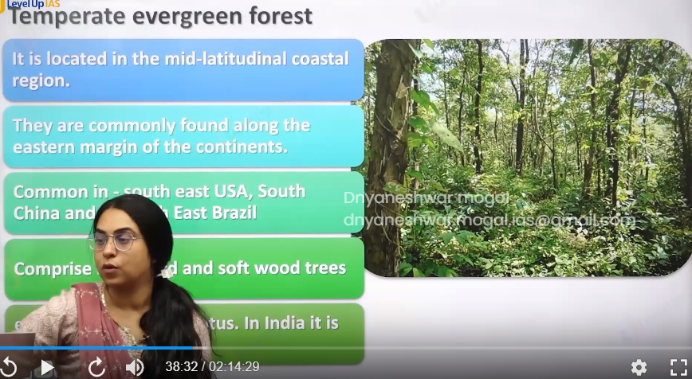

Temperate evergreen forest:

1. It is located in mid latitude and margin of continents. They comprise of sold wood and hard wood species but solfwood dominiate.
2. They are wild used for furniture and matchstick production paper production.
3. In India temperate every green forest are seen majorly in the Himalayas the name of species are oak pine eucalyptus.

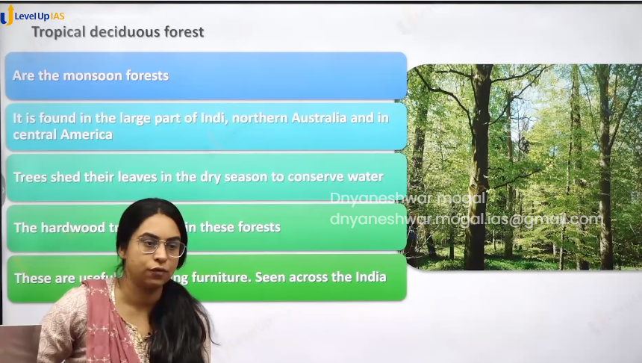

Tropical deciduous forest:

1. They are also known as monsoon forest
2. They are two types moist decedo00us forest and dry deciduous forest.
3. They are found in large part of India, Brazil, Mexico, some parts of Africa, Australia.
4. Tree shades their leave to conserve their moister. There is a mixture of softwood and hard wood. They are used for furniture.
5. Ex teak, sag, neem, Shisham.

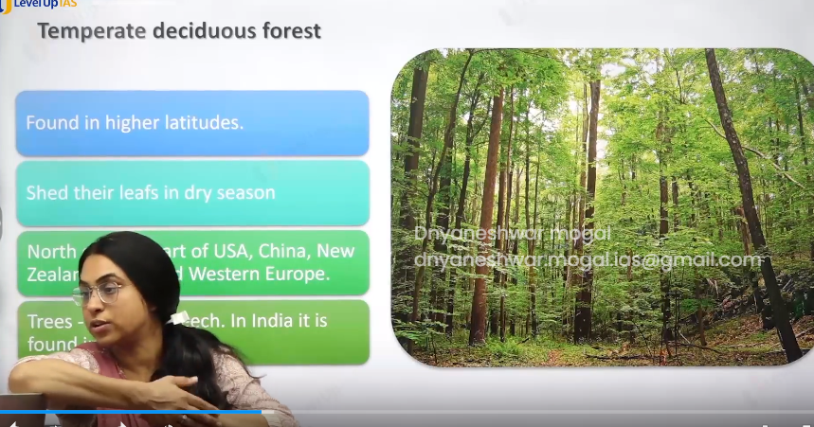

Temperate deciduous forest:

1. It is found in higher latitudes 15 degrees north and south.
2. Tree shade their leaves in dry season, They are found along the margin of temperate ever green forest, ex USA, China New Zeeland, western Europe, chili,
3. Species oak, ash, beech

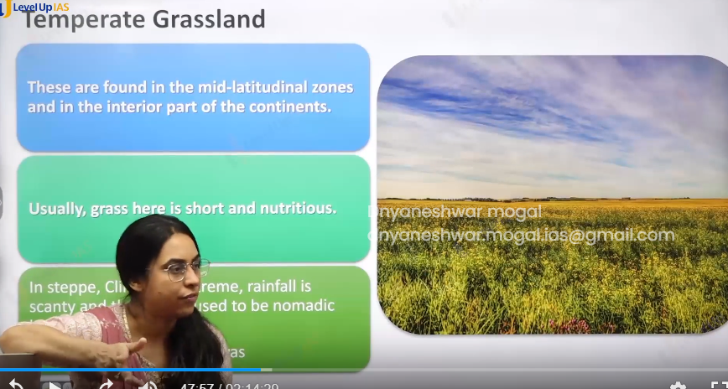

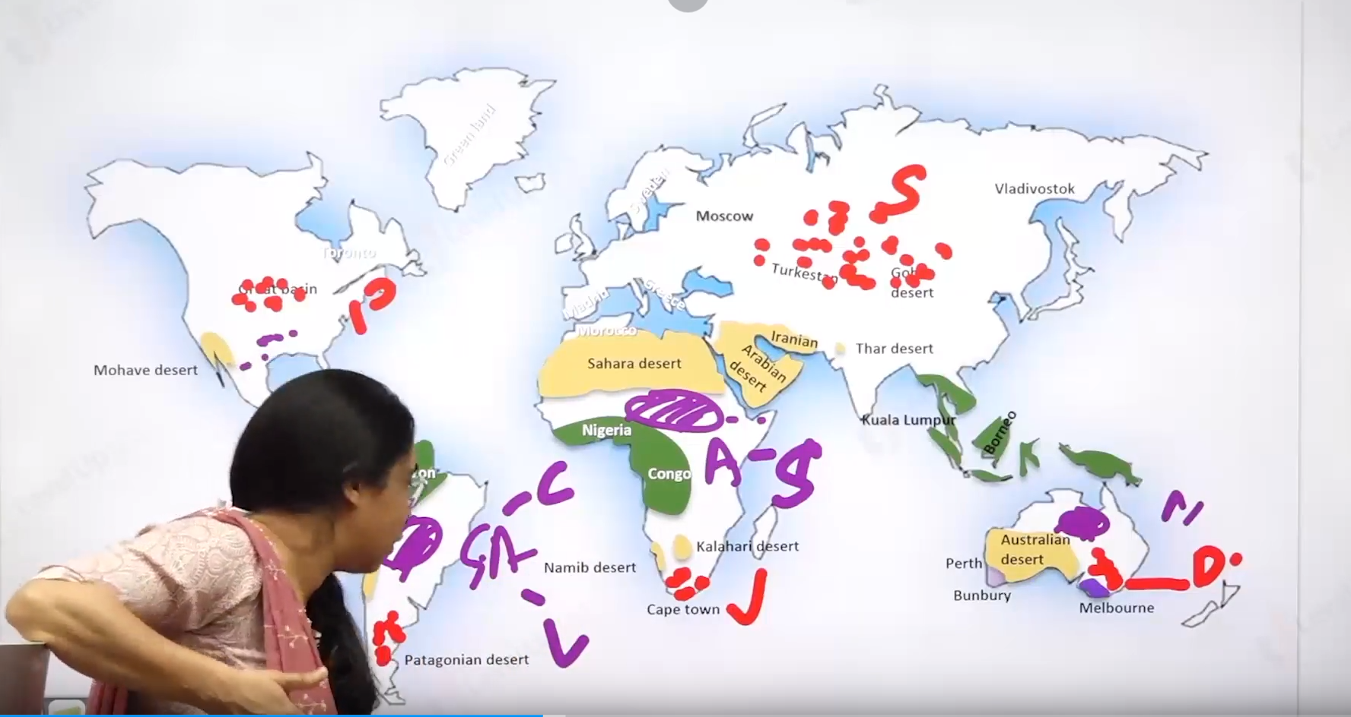

The violet ones are tropical grassland

And the red ones are temperate grassland.

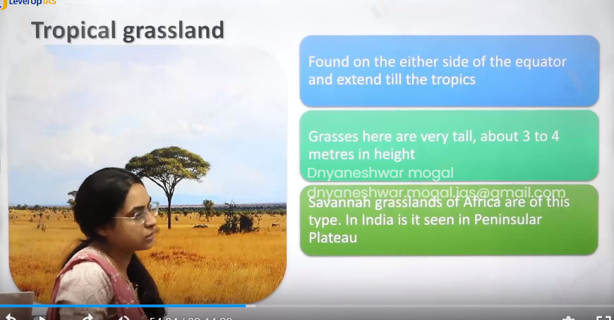

Tropical Grasslands:

1. They are found on either side of tropics, where there is moisture stress.
2. These grasslands are very tall and may reach 3 to 4 m height. Tropical grasslands are not pure grassland, there is a mixture of tree and grassland.
3. Grasses have become resistant to fire due to a lot of fire in the dry seasons, therefore this ecosystem is also called fire climax community.
4. Tropical grassland are not nutrients compared to temperate grasslands. Because grass need cold climate for better nutrition as well as the soil in region of tropical grassland Is not as nutrient rich
5. Ex: savannah in Africa, Llanos south America, Compos in south America.

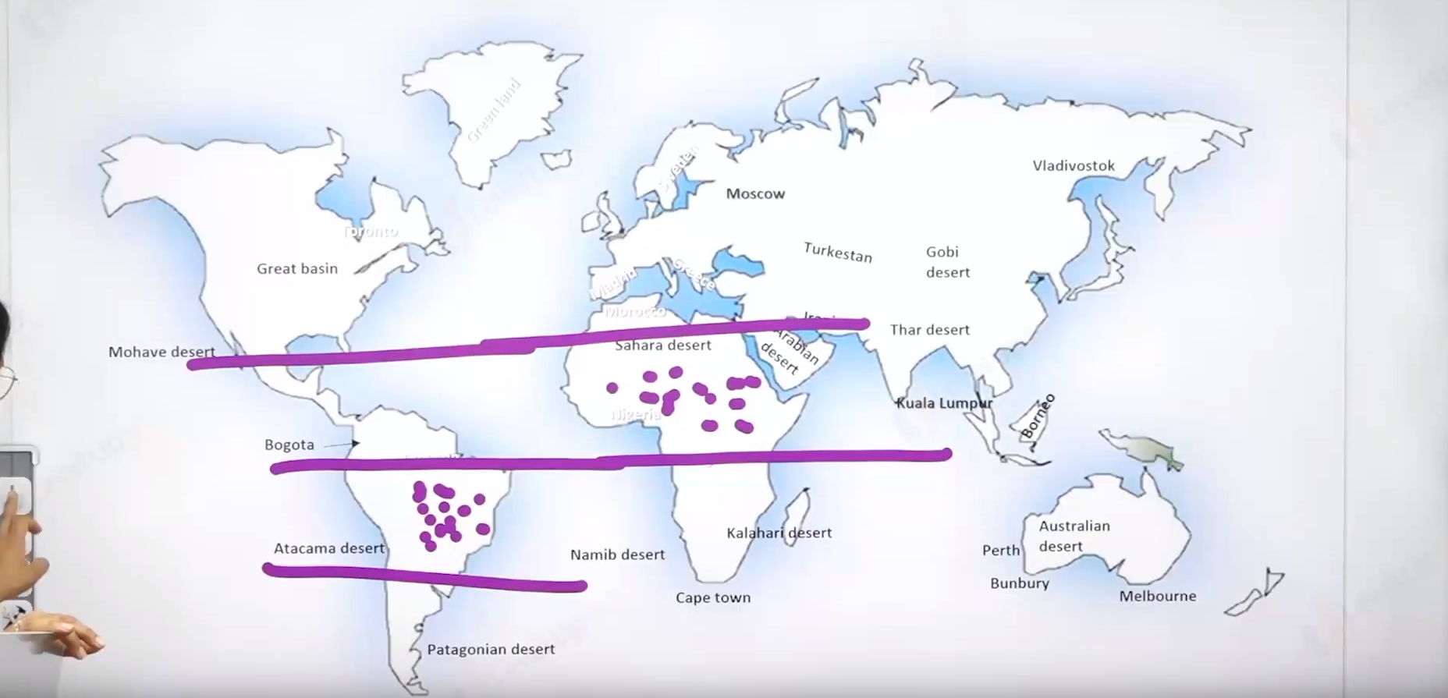

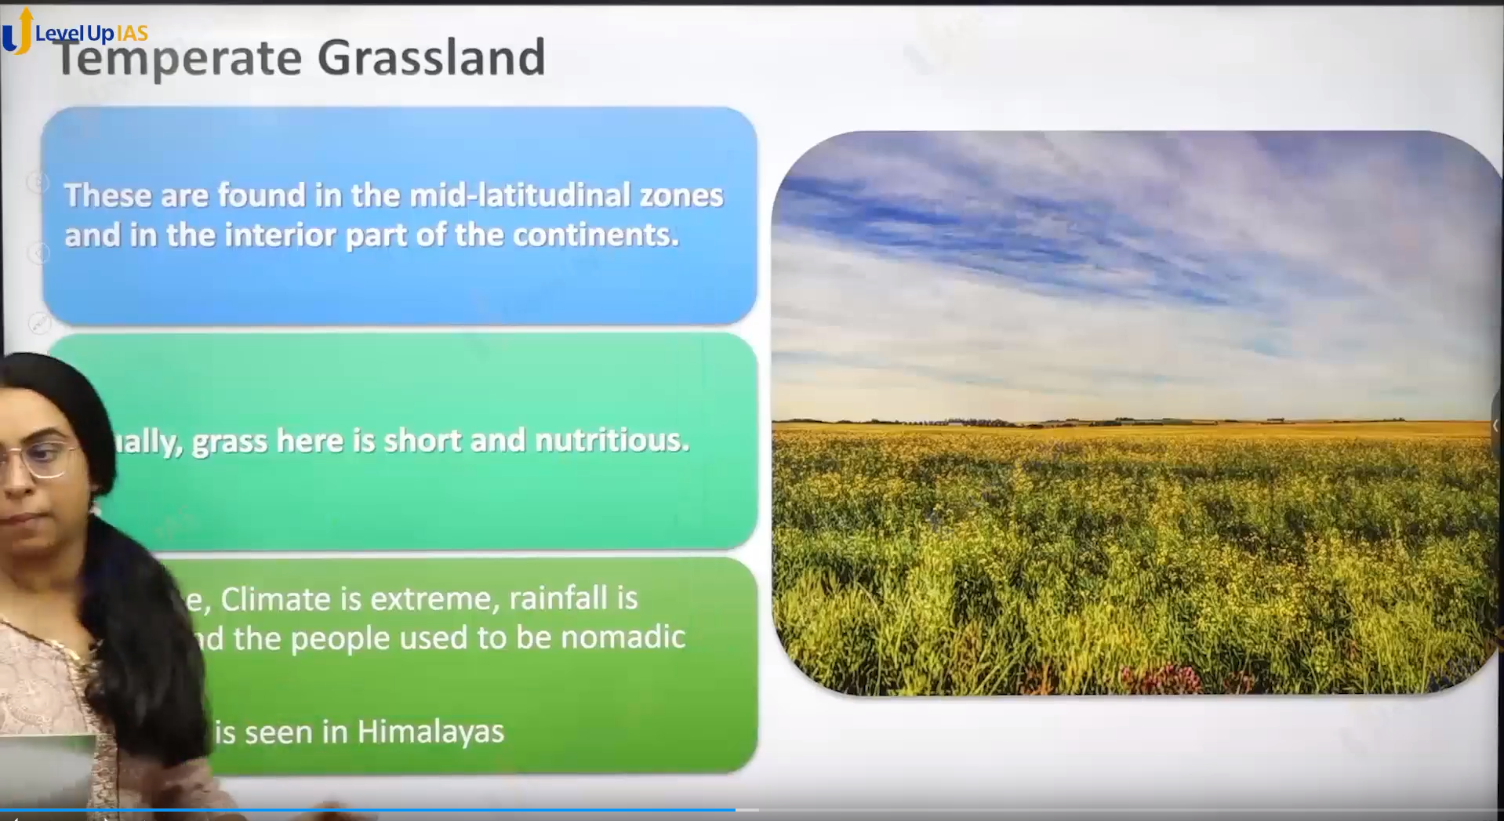

Temperate Grassland:

1. They are found in mid latitude zone in the inner part of continent
2. The grasses are usually short usually nutritious ex: steppes in Russia, pampas in Argentina, Pustaz in hungry, veldts in south Africa. Prairies in north America (they are little on the wetter side) and downs in Austria.
3. They are pure grassland unlike savannah.

Difference

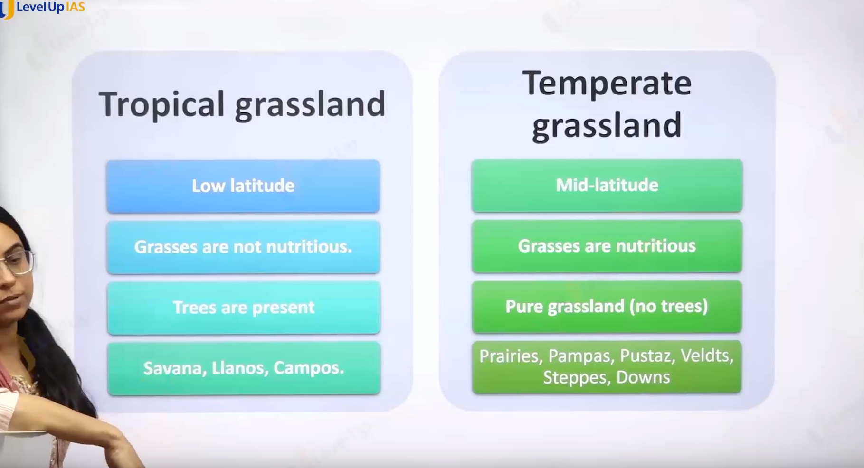

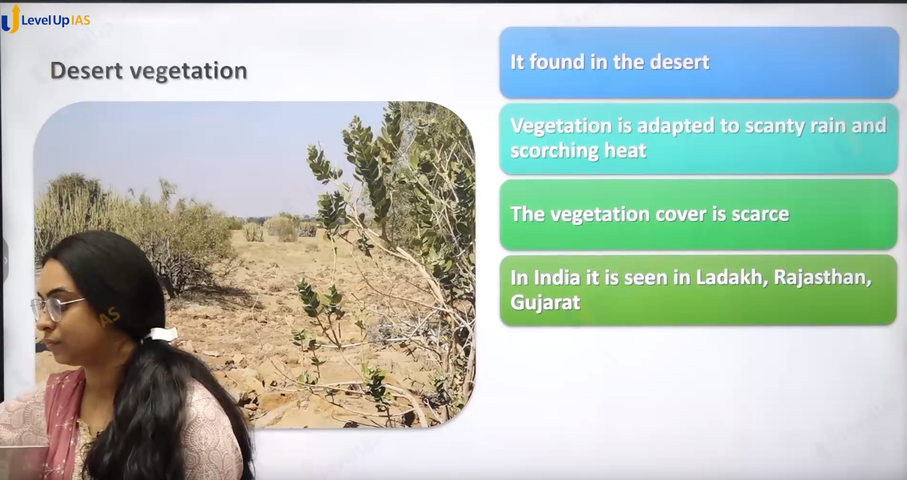

Desert Vegetation:

1. It was found in the desert. They vegetation scars and vegetation are adapted to water stress. In India desert vegetation is seen In the Ladakh, Rajasthan, Gujarat.
2. The tree adaptation is like long cap roots to reach ground water, horizontal to search water. Seed lies dormmate for years, and quickly germinate when it rains. Tree store water in the root stem leaves fruit and they are called succulent.
3. Leaves they become small and they can become Thorn or they can become waxy and leather with sunken stomata to conserver the water loss.

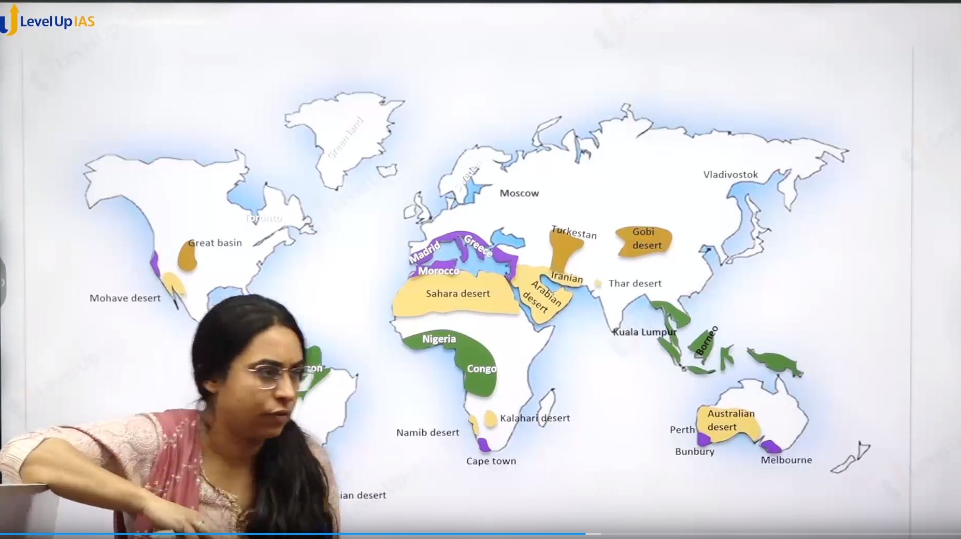

It is show in the purple color.

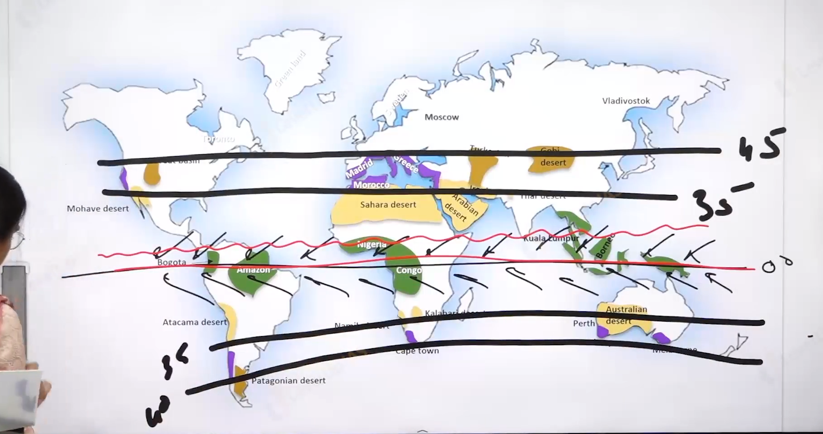

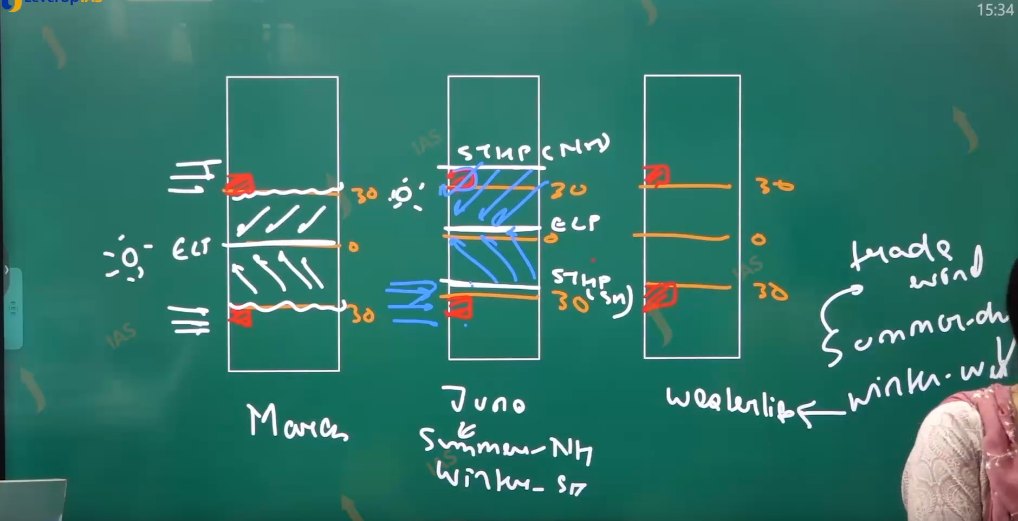

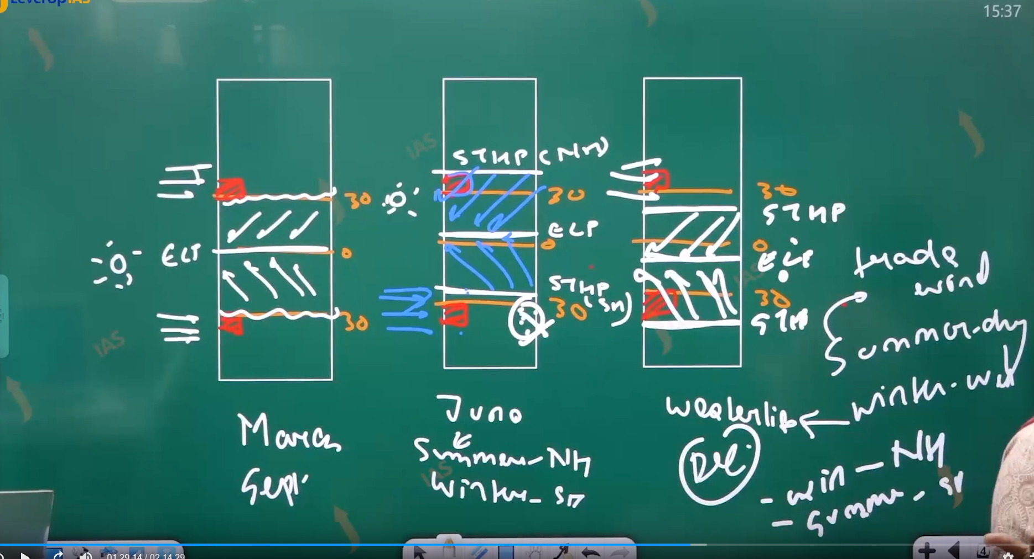

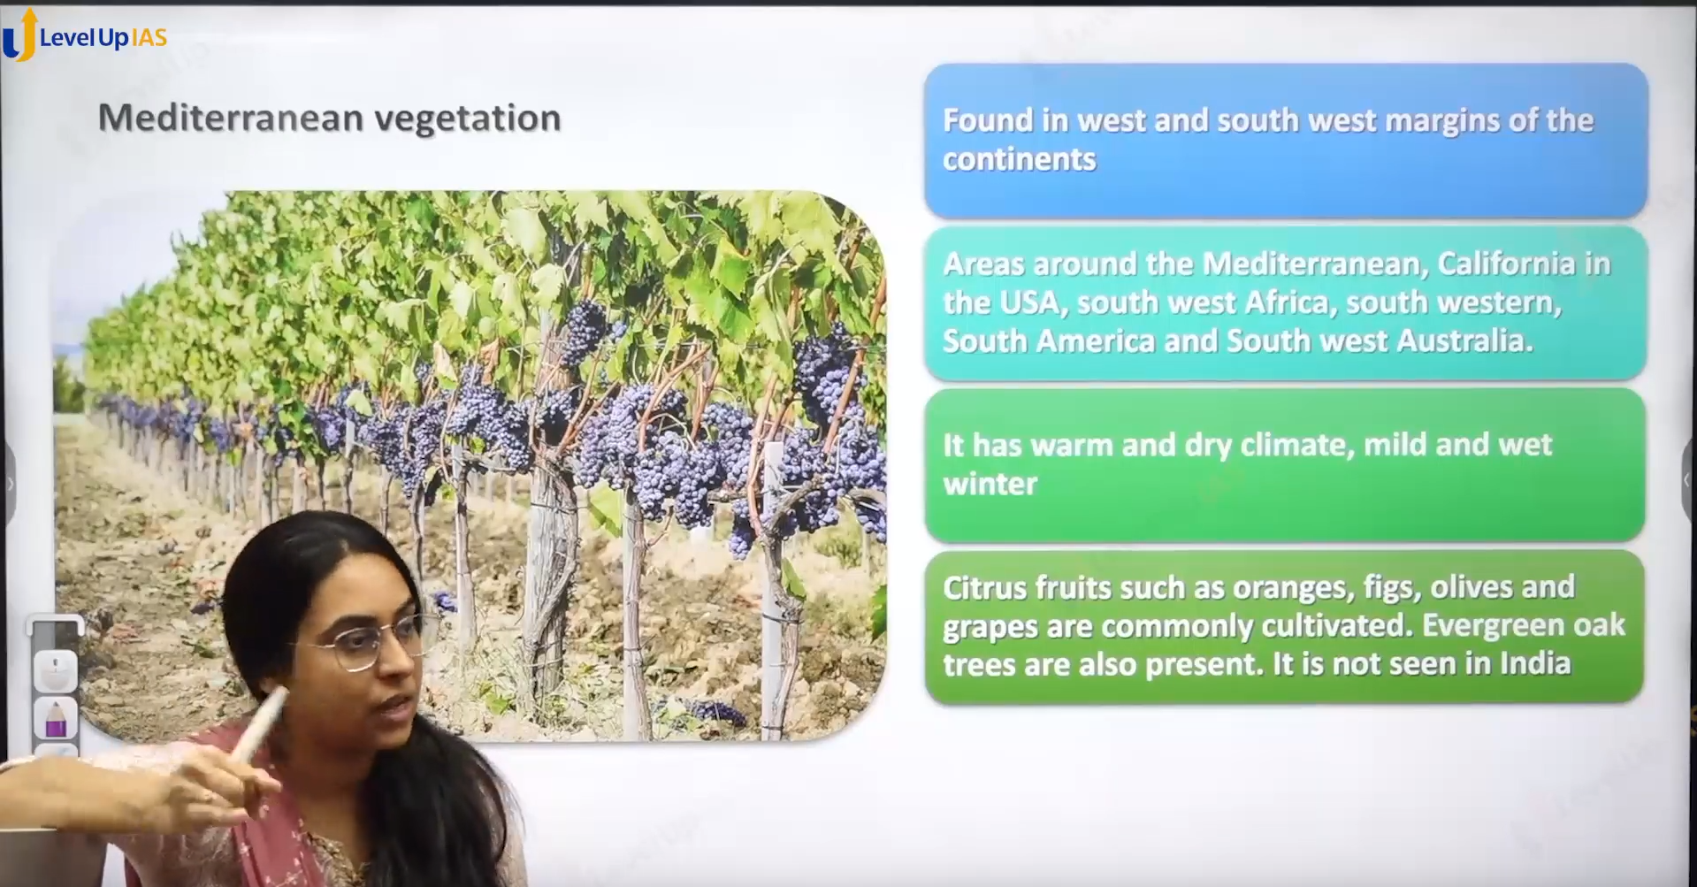

Mediterranean vegetation:

1. It found the in the western side of continent between 35 – 43 degrees north and south.
2. It was found in the Mediterranean climate which has special conditions like rainfall in winter due to westerlies winds dry condition in the summer due to offshore trade winds.
3. The Change in the pattern is due to shifting pressure belt with apparent shift of sun.
4. It seen the area of Mediterranean coast, California of USA, southwest Africa, southwest Africa, southwest America, the southern part of Australia.
5. The vegetation grown here are citrus fruits like oranges and gigs olive jalapeno, grapes, ever green oak tree also present this type of vegetation is not seen in India.
6. It also known as sclerophylls

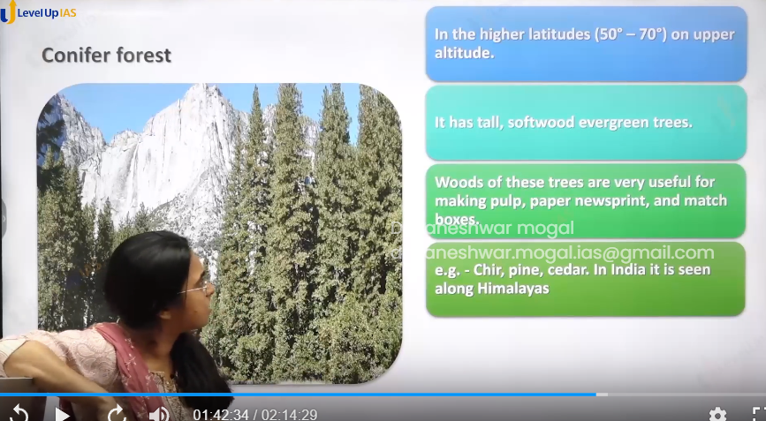

Conifer forest/ vegetation:

1. It was found in the higher latitudes 60-70 degrees north and in upper latitudes. It has tall soft wood ever green trees. Wood is used for making pulp paper newspapers. Chir pine and cedar it seen along the Himalayas.

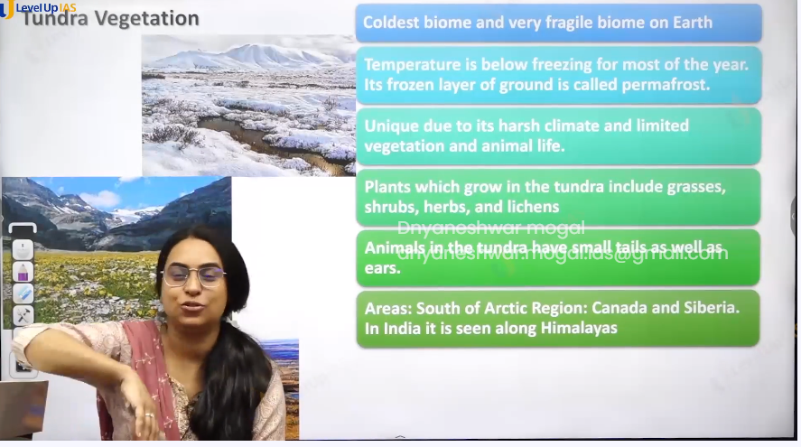

Tundra Vegetation:

1. Coldest biome. And very fragile biome on earth
2. The temperature is below the freezing point of water for most of the year and therefore the frozen layer of ground is called frame forest.
3. It is a unique vegetation which adapted to harsh life /climate therefore it has limited vegetation and animal life.
4. The plants that grow in tundra vegetation are grass herbs lichen shrubs.
5. The animal in tundra is small tail and small ear. It found in the region in the Canada Siberia greenland Himalayas.

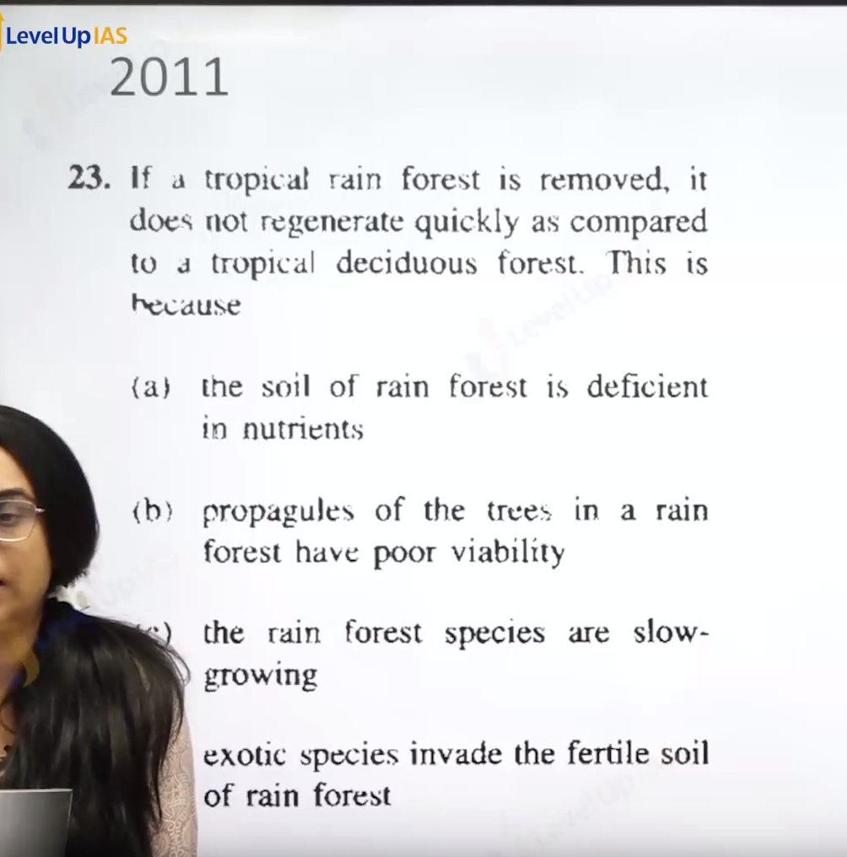

Ans A.

Vegetation of India:

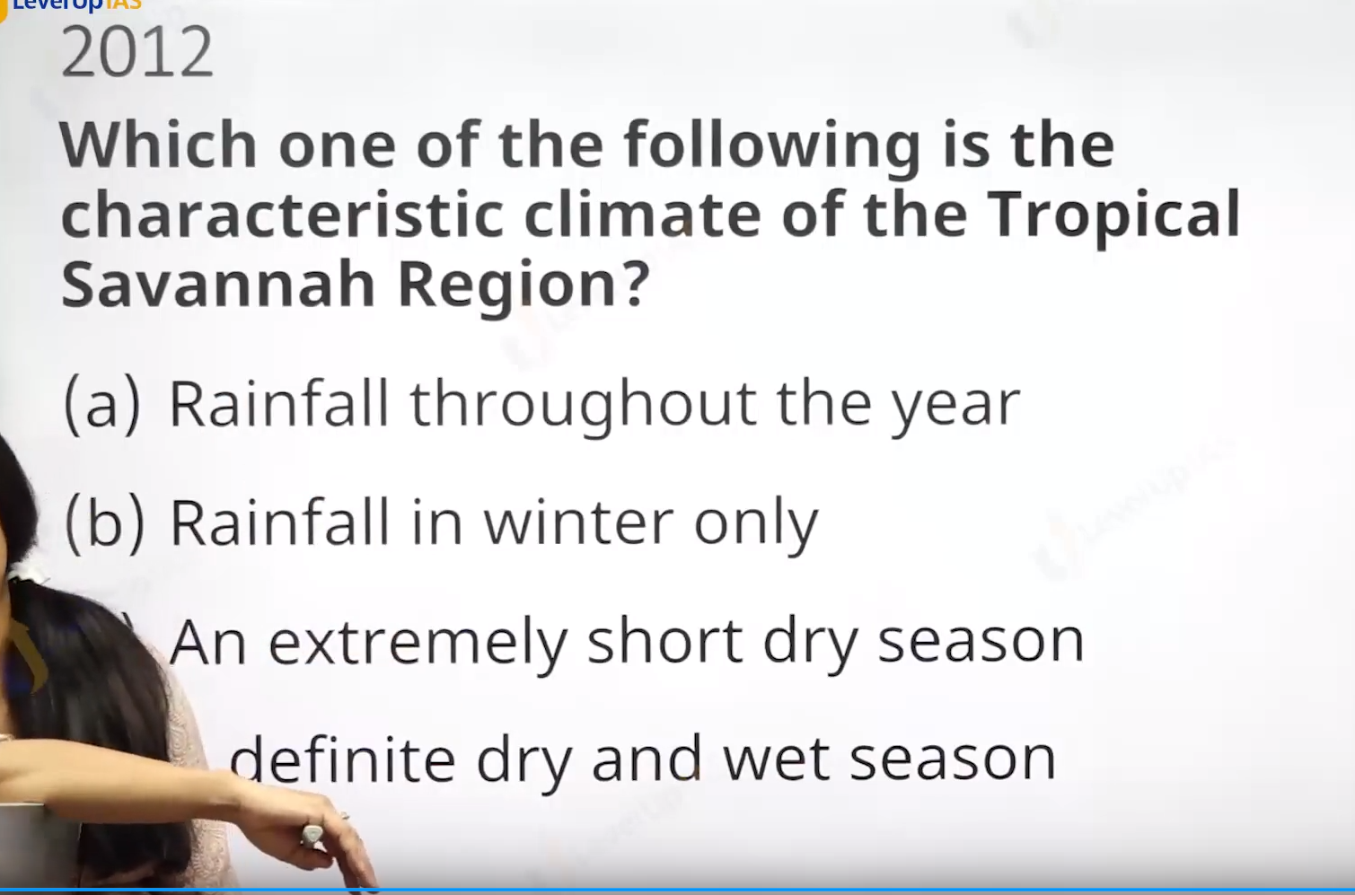

Ans d

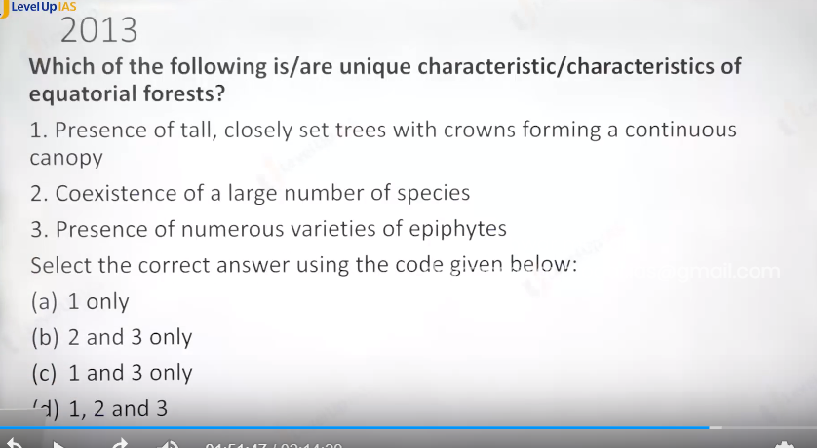

Ans Is D

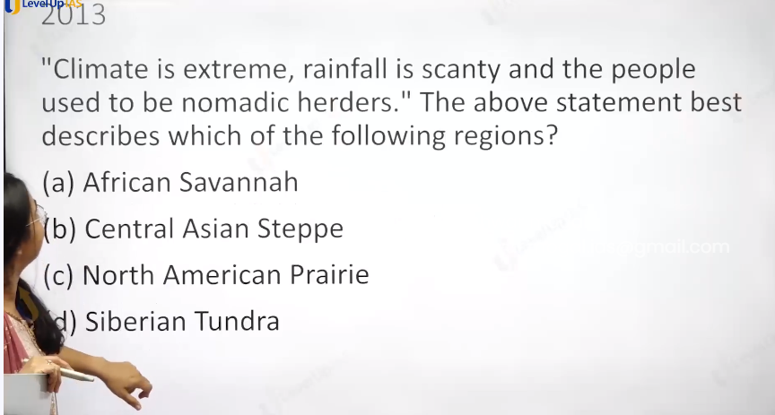

Ans B.

Trundra do not have the livestocks. Not d

Prairie is good rainfall.

Savanna not extreme climate.

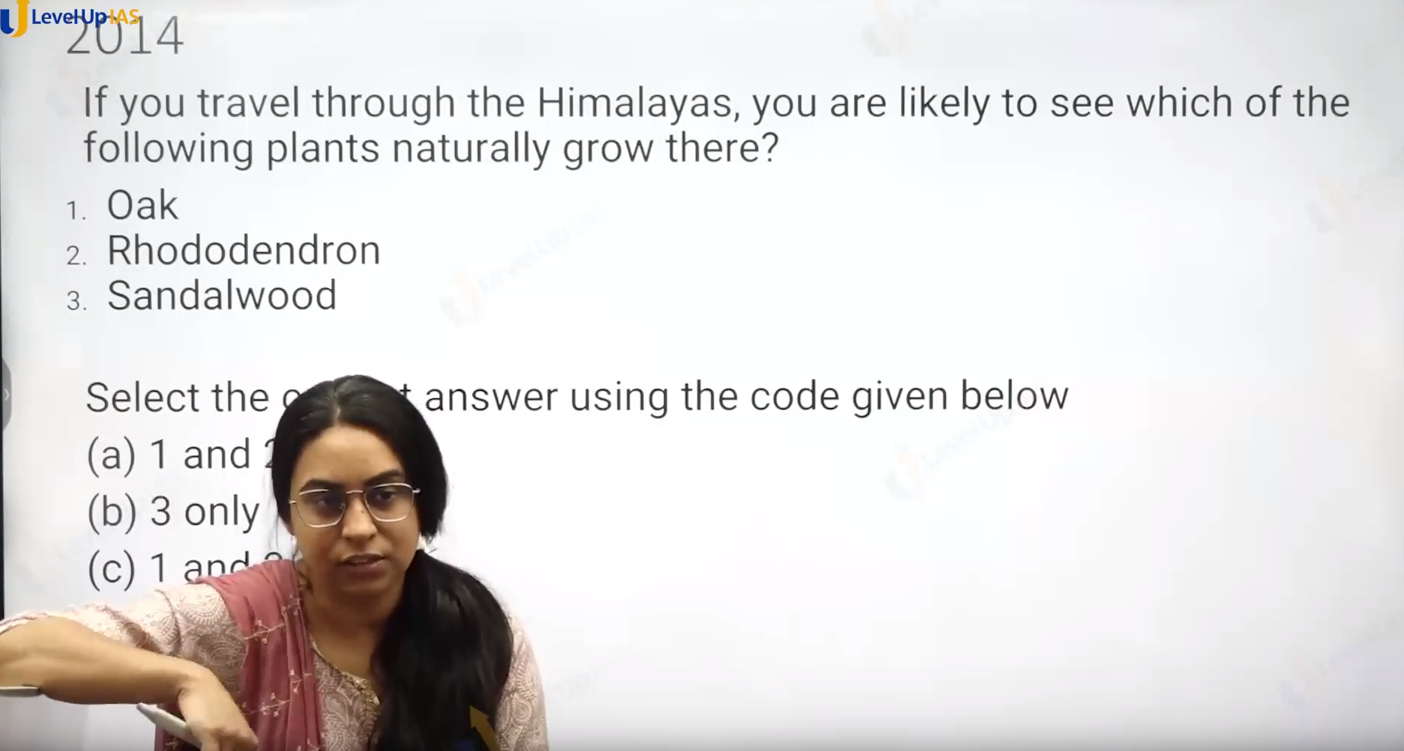

Ans is a not sandhood.



Meghalaya.

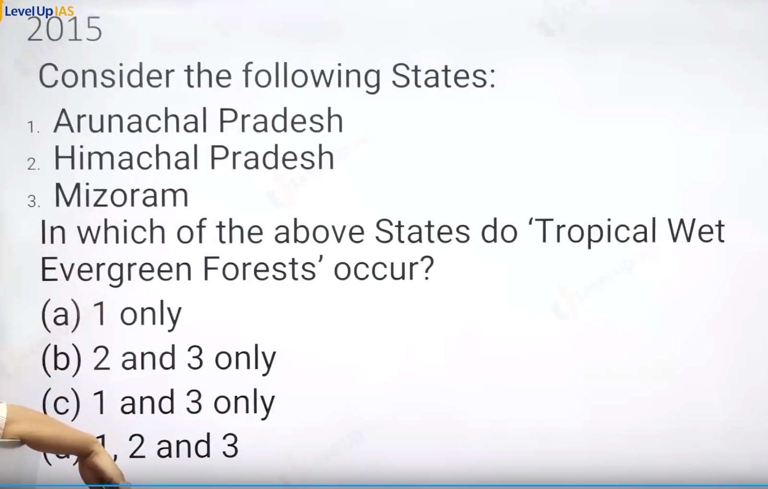

Ans is C.

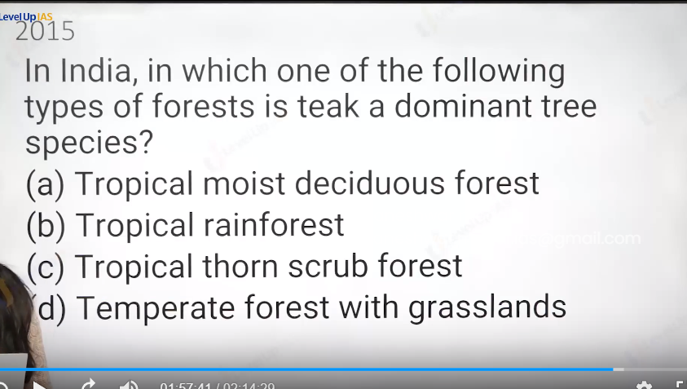

Ans a.

Tropical evergreen forest : rosewood mahagani ebony

Tropical throono : babool cactus

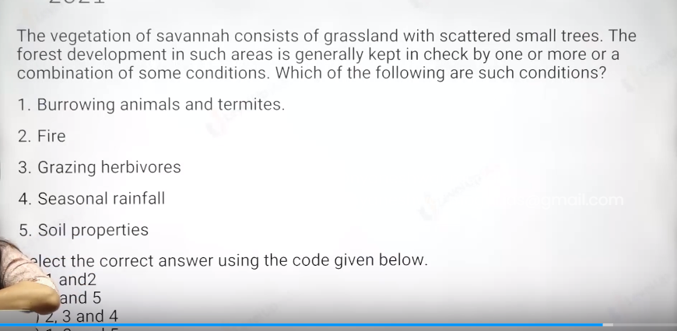

Ans id C

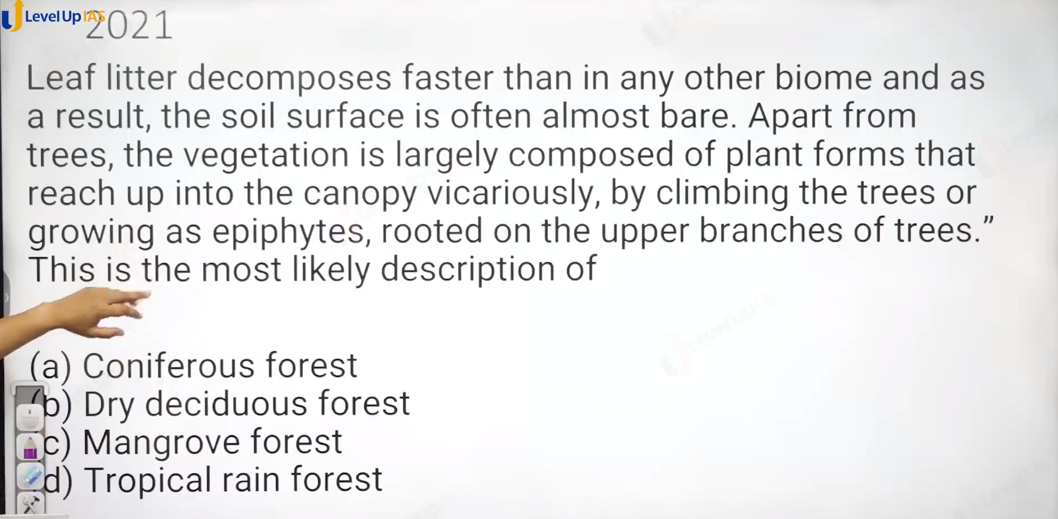

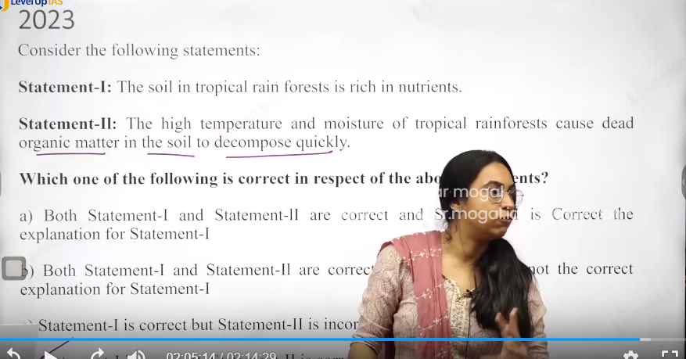

Ans d. first is wrong

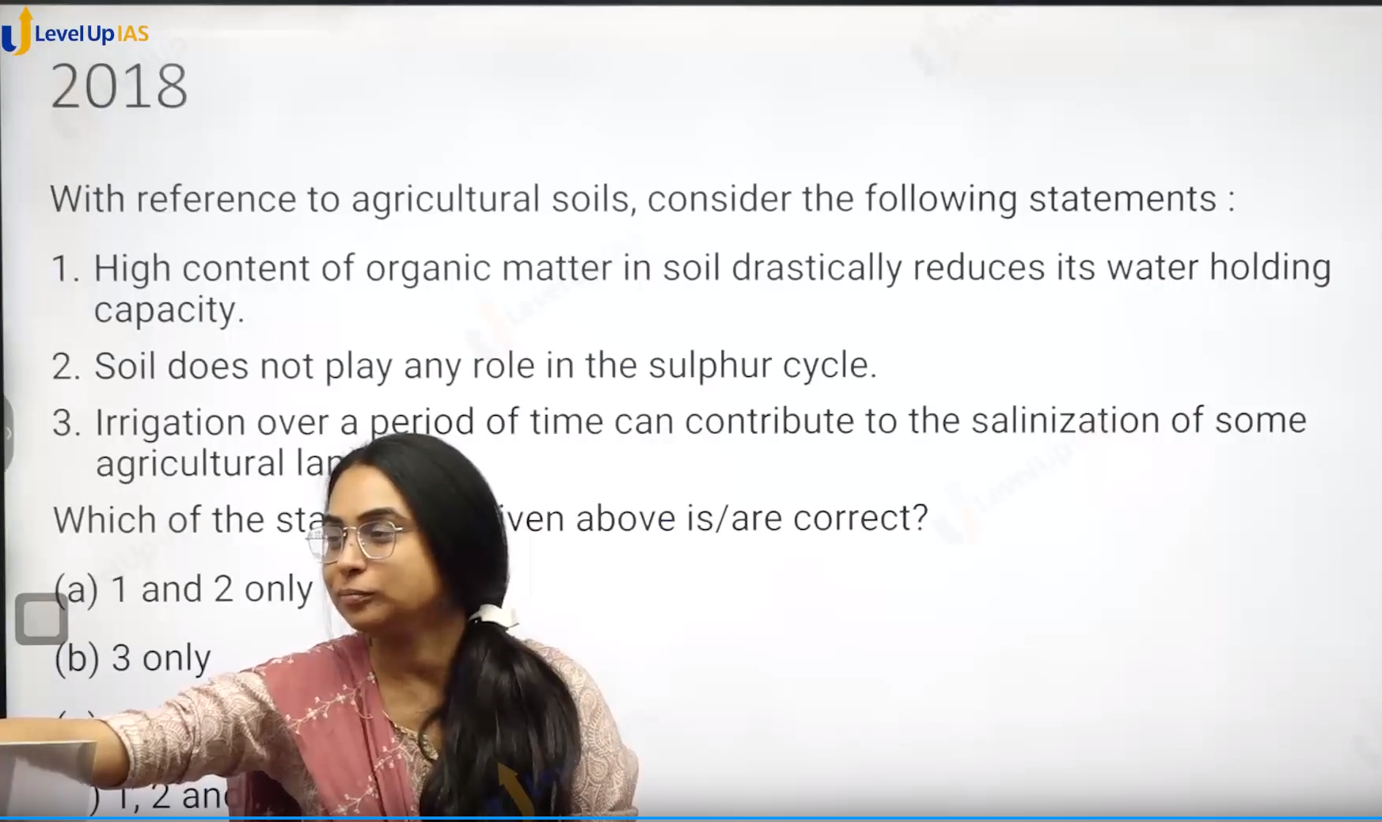

Vegetation of India:

1. You have wet ever green forest, moist ever green forest. Monsoon forest, deciduous forest, throne forest. xerophyte. Montaine forest, mangroves: -shola forest.
2. Wet ever green forest: rainfall > 350 cm/ Year
3. Moist ever green forest: rainfall >250 cm /year
4. Dry semi ever green forest: 200 cm
5. Monsoon forest: rainfall 75 -150 cm/year.
6. Dry deciduous forest: 75-100
7. moist deciduous forest: 100- 150
8. thorn forest: 75
9. xerophyte: 45 :
10. mangroves are : tidal halo phytic plant.

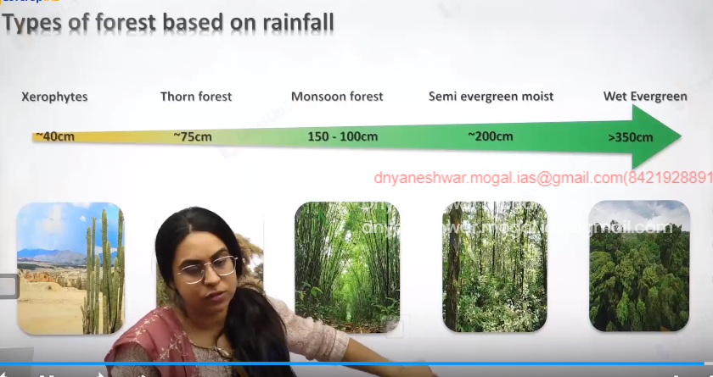

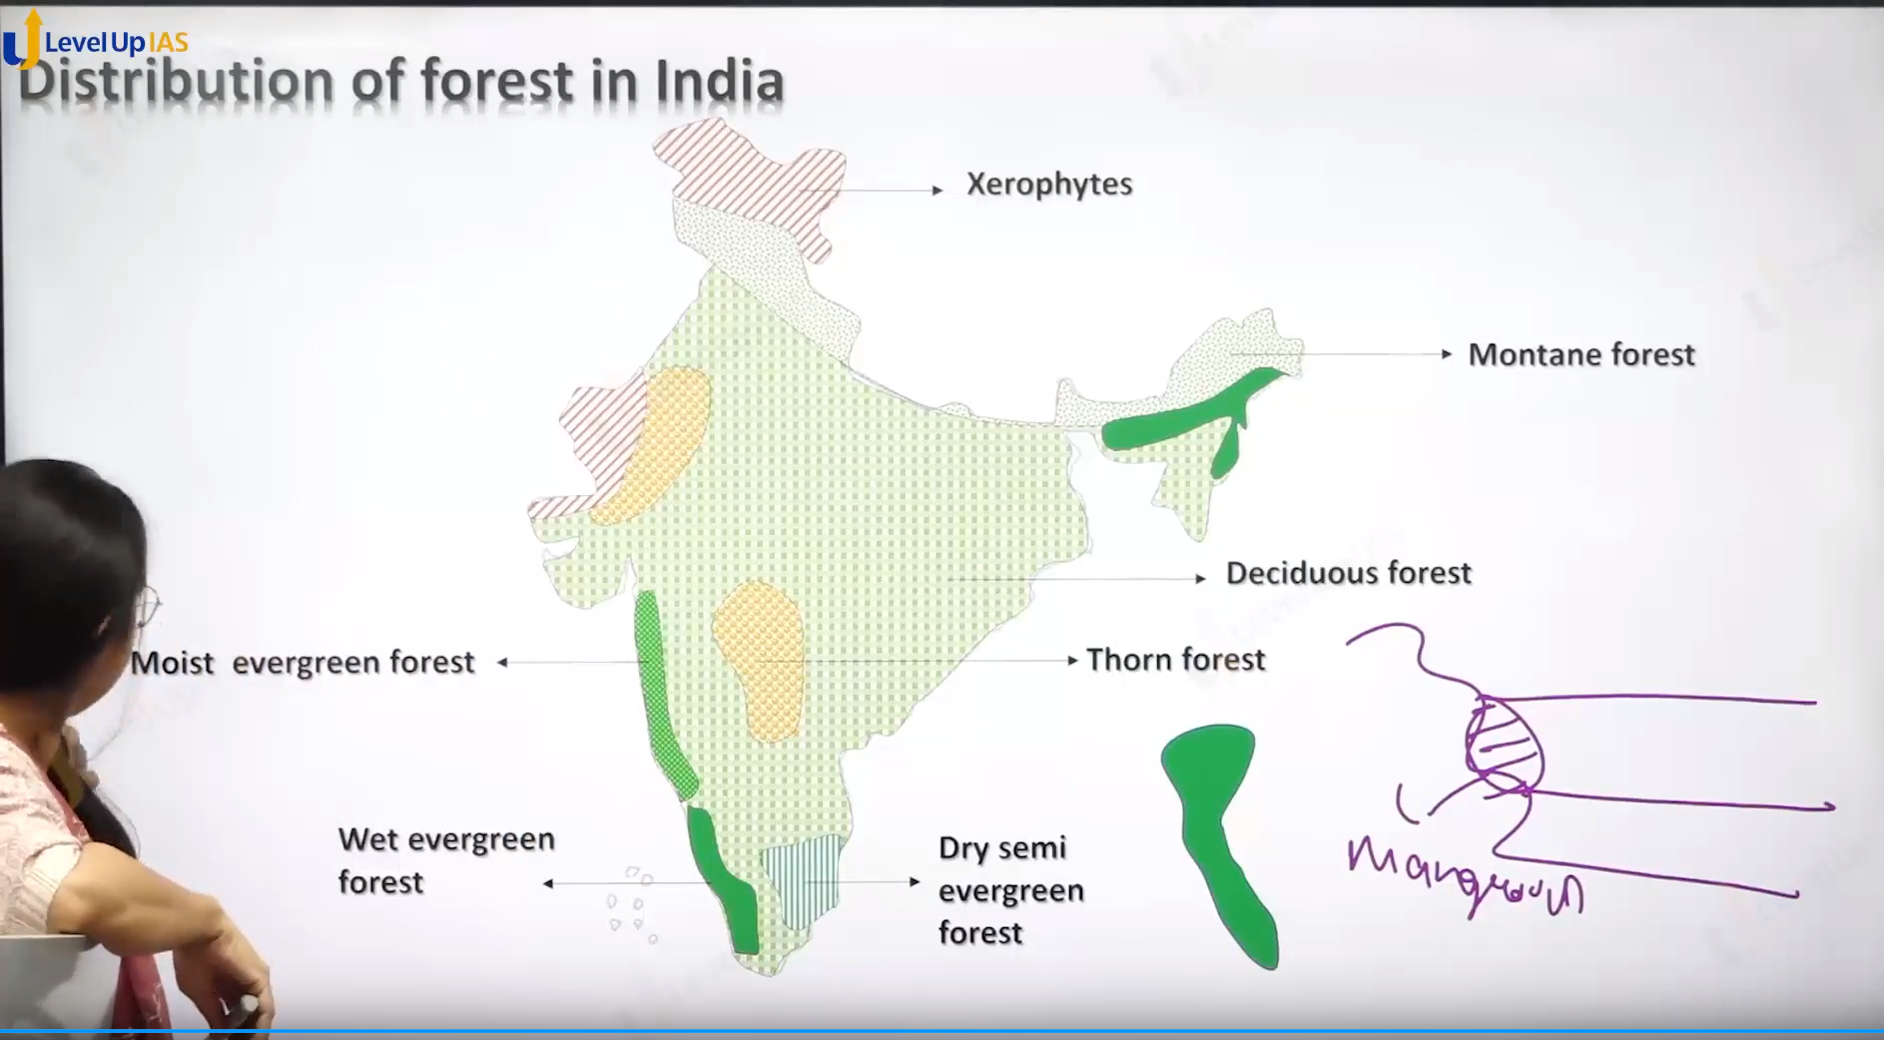

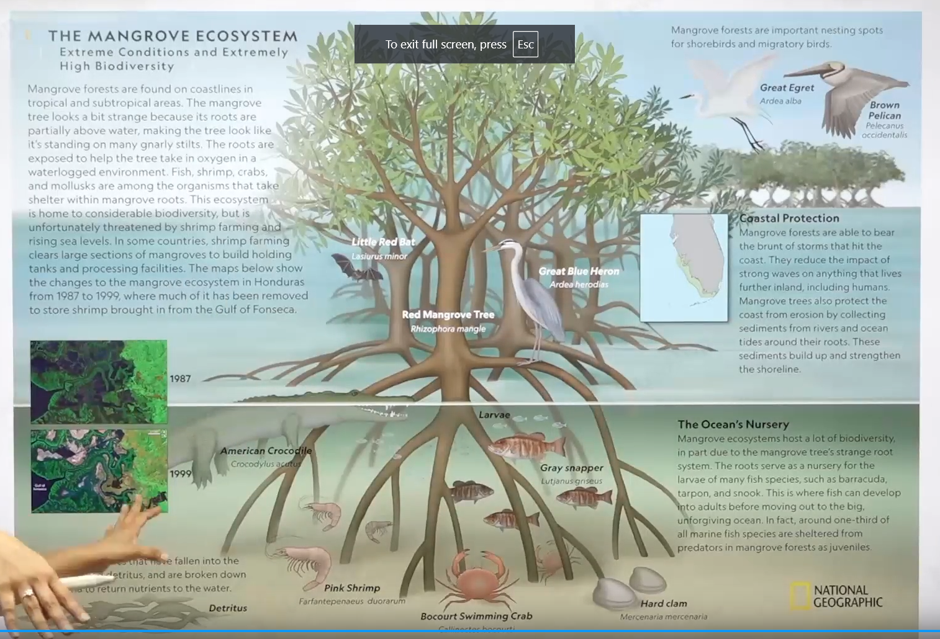

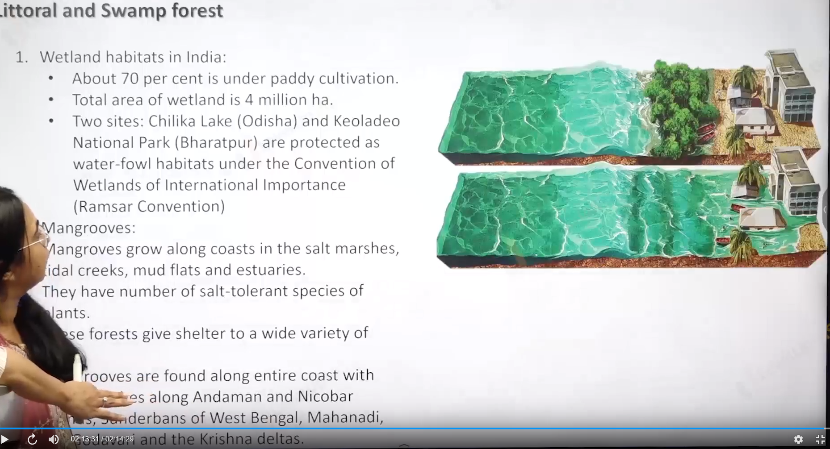

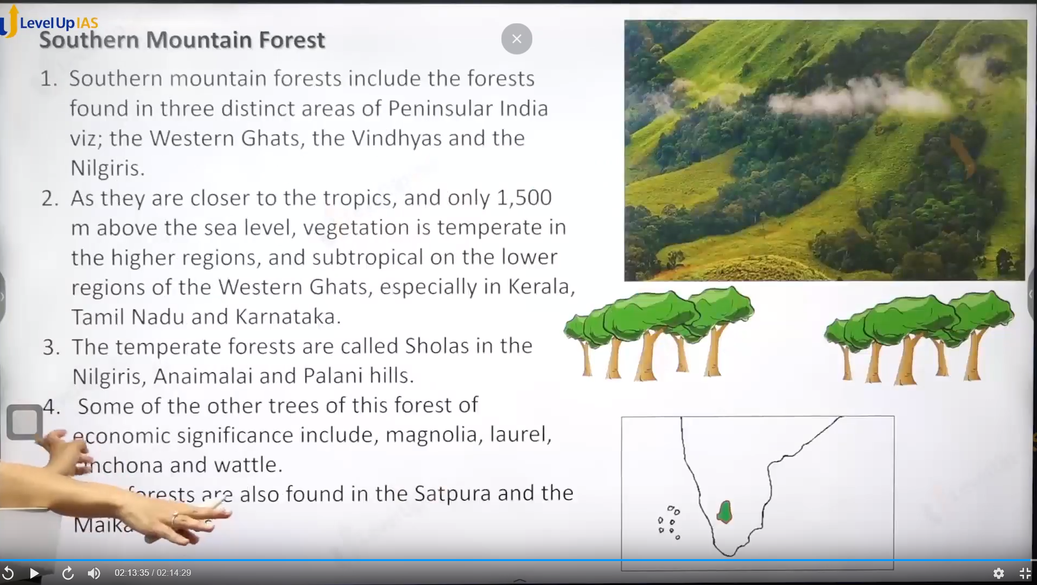

# (35) Vegetation and Soil-II

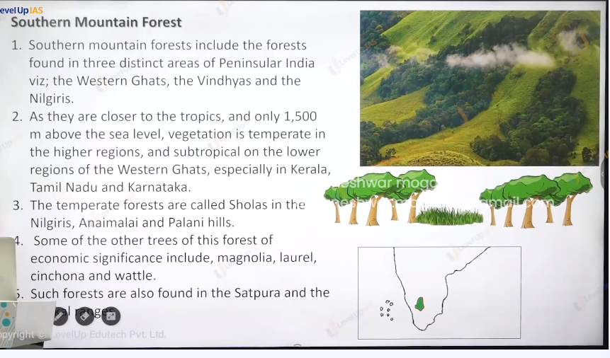

Southern Mountain Forest:

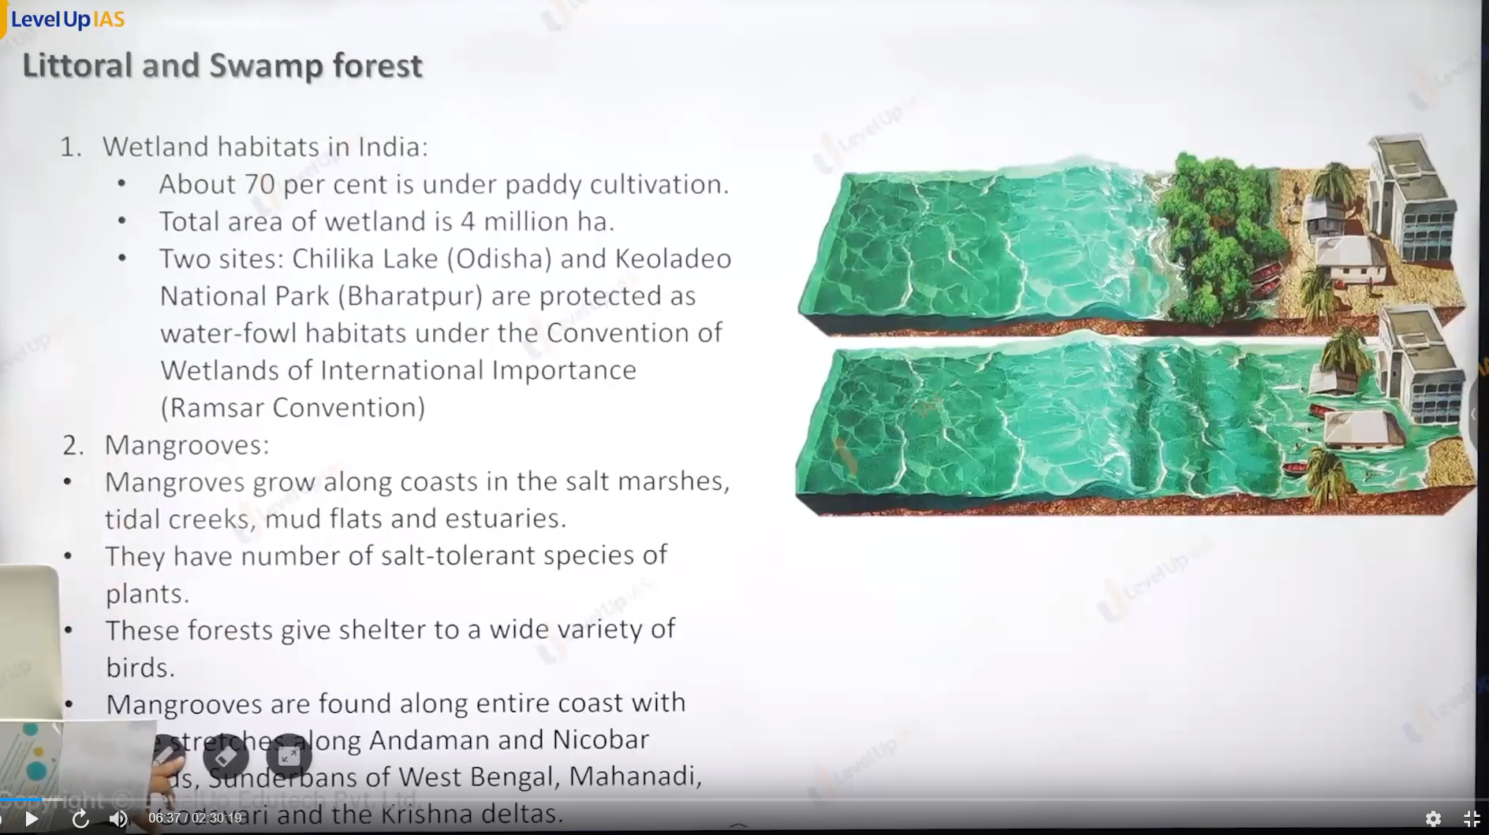

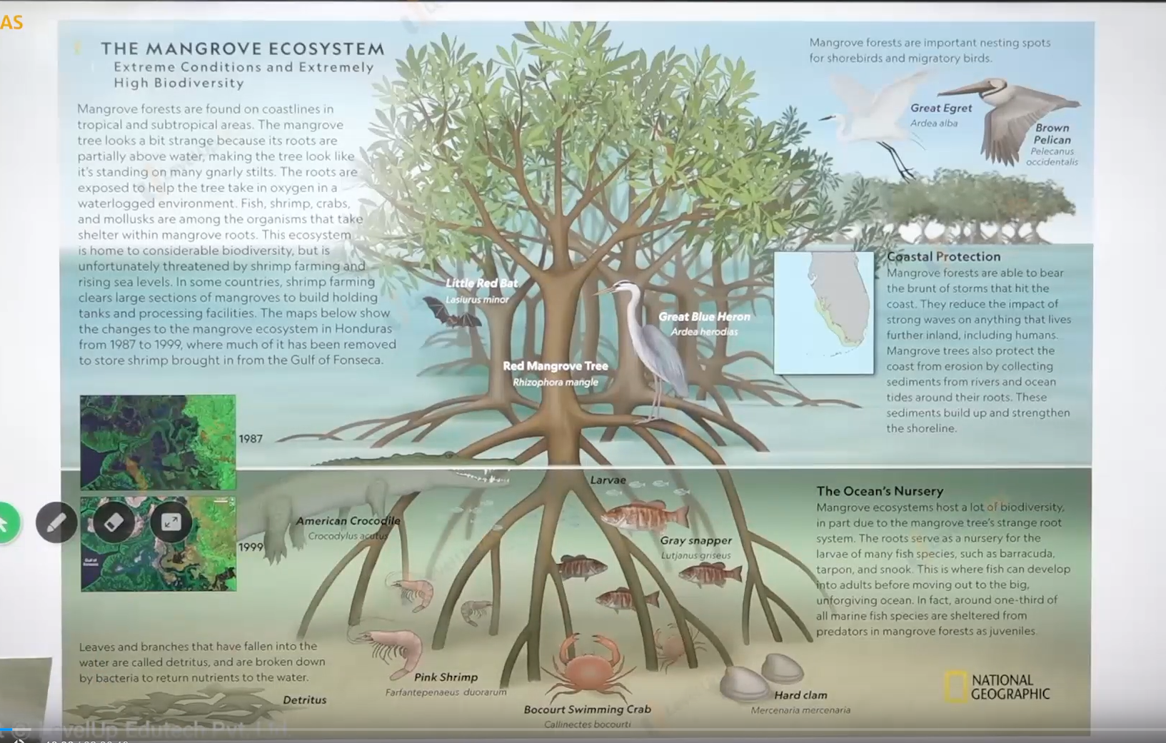

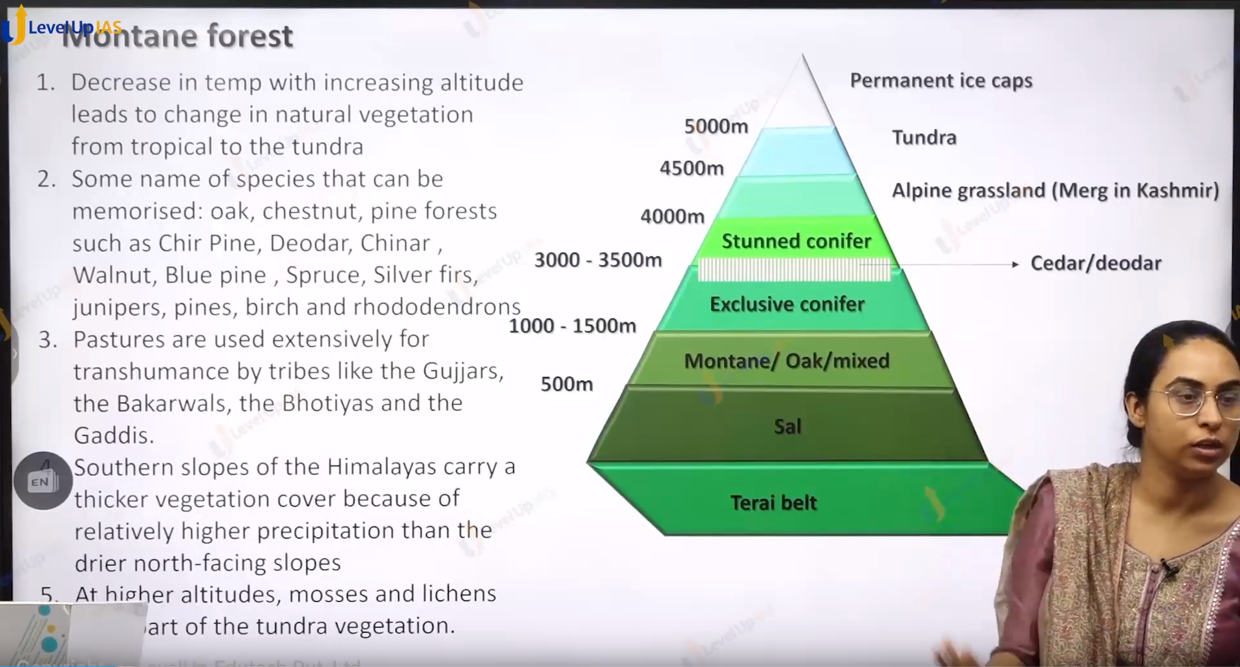

Indian vegetataion contains:

1. Tropical Every green forest:
2. Tropical Deciduous forest:
3. Temperate Decious Forest:
4. Temperate every green forest:
5. Tropical grassland:
6. Temperate grassland:
7. Tundra.:
8. Southern mountain forest:
9. Mangrove
10. Wetlands.
11. Northen montane forest:

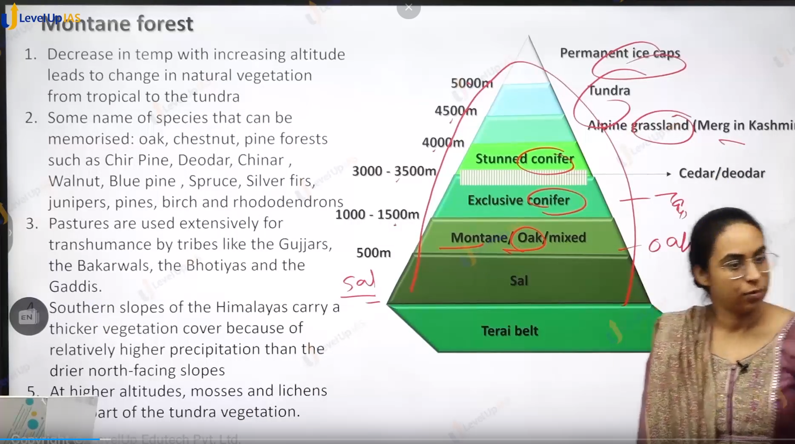

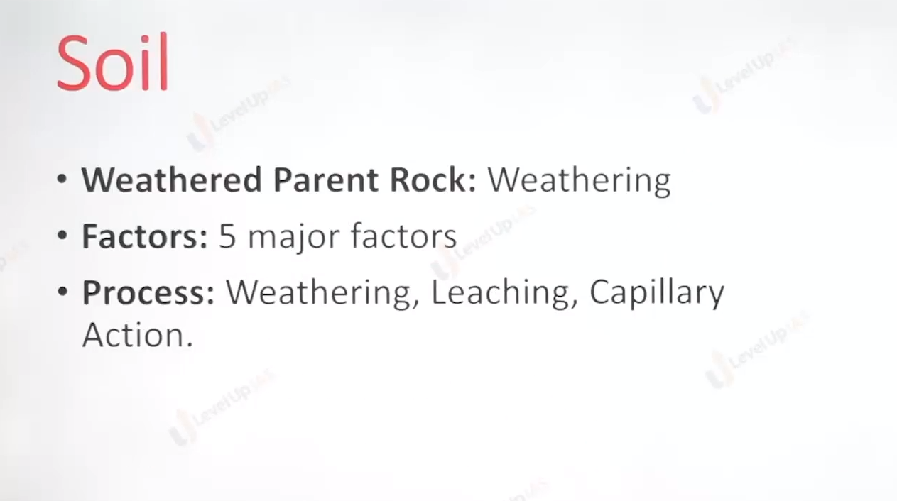

Soil

1. Soil is not simply dirt or broken rock particles but is complex ecosystems in which factor like time, biota , climate play an important role.

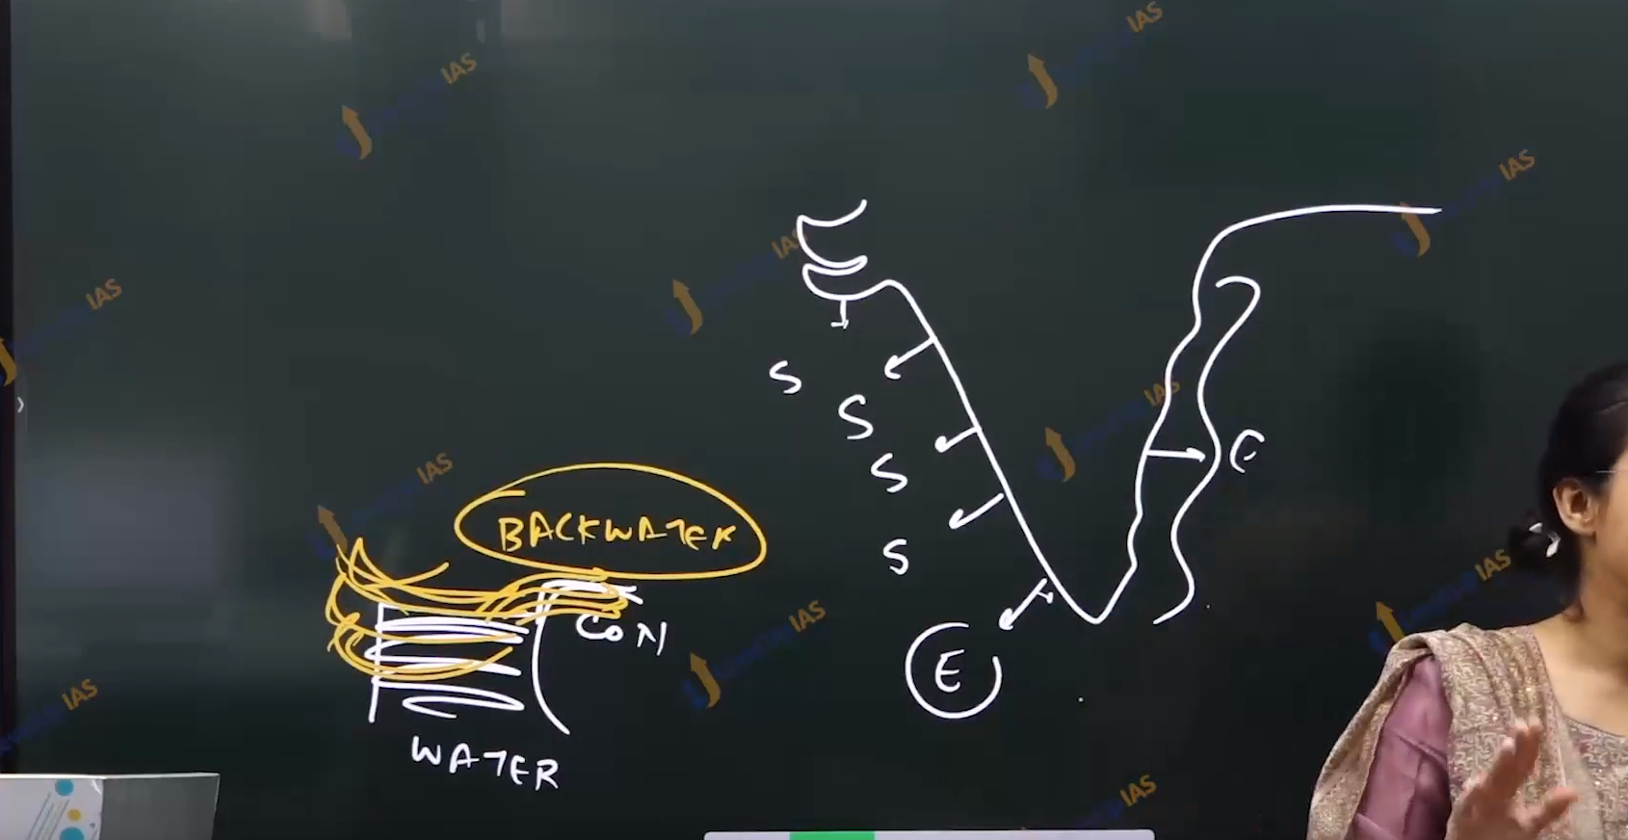

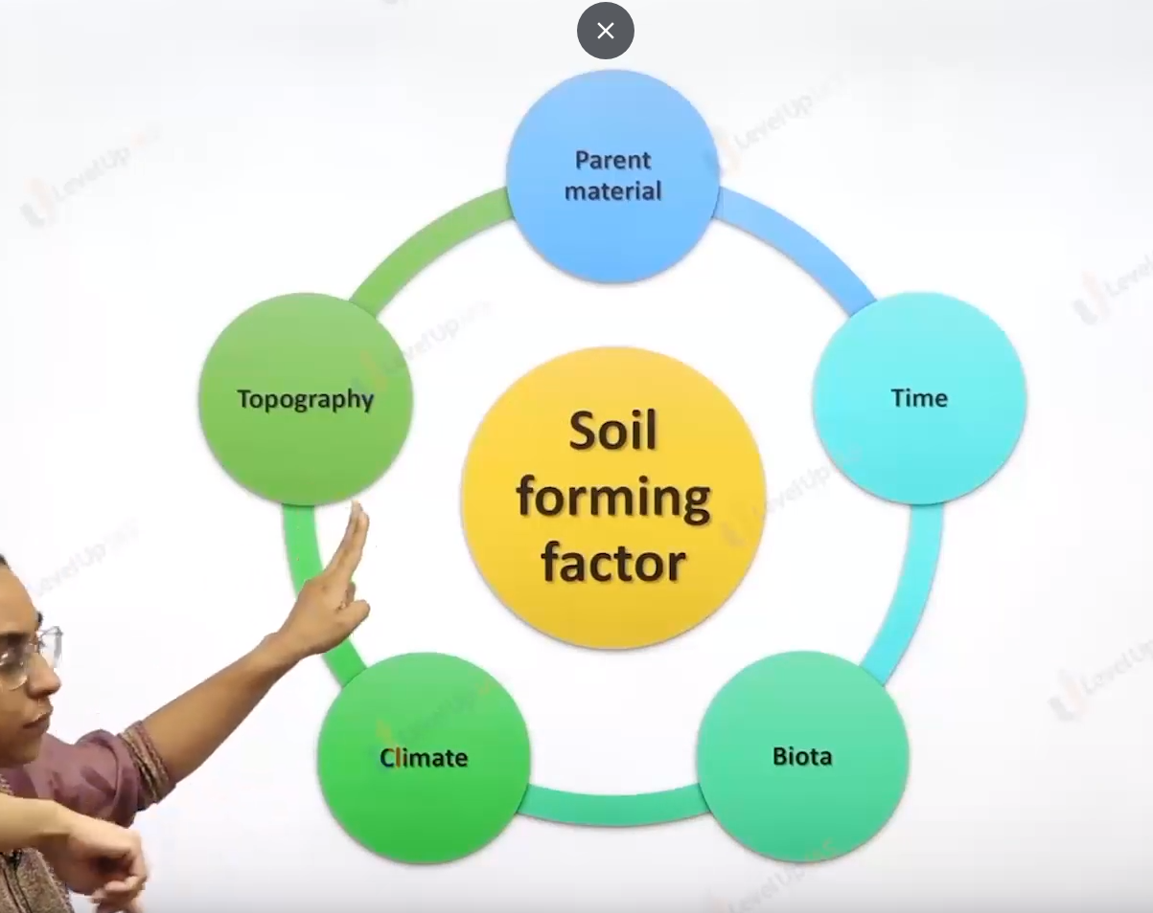

S for submergence

E for emergence.

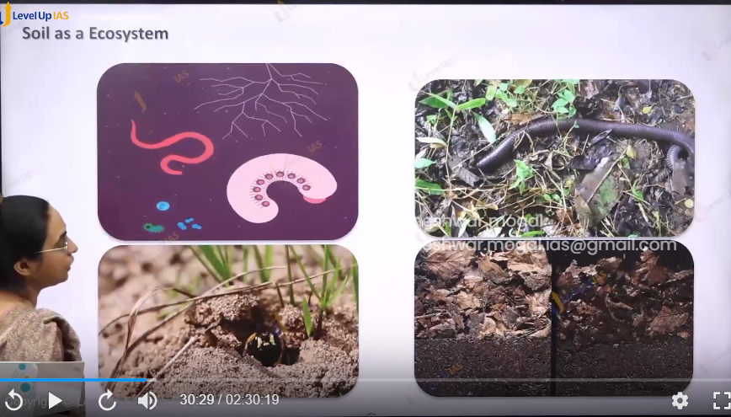

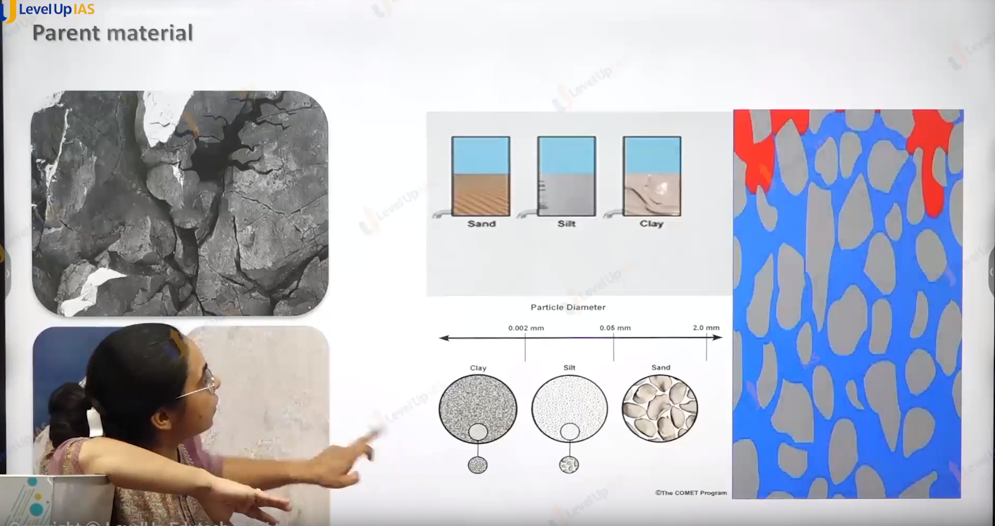



Soil Forming Process:

1. Weathering
2. Translocations ( water goes down in soil or earth)
3. Leaching ( nutrient go down when rains ) .
4. Unifaction.( formation of unmoors)
5. Transformation of dirt in the soil.

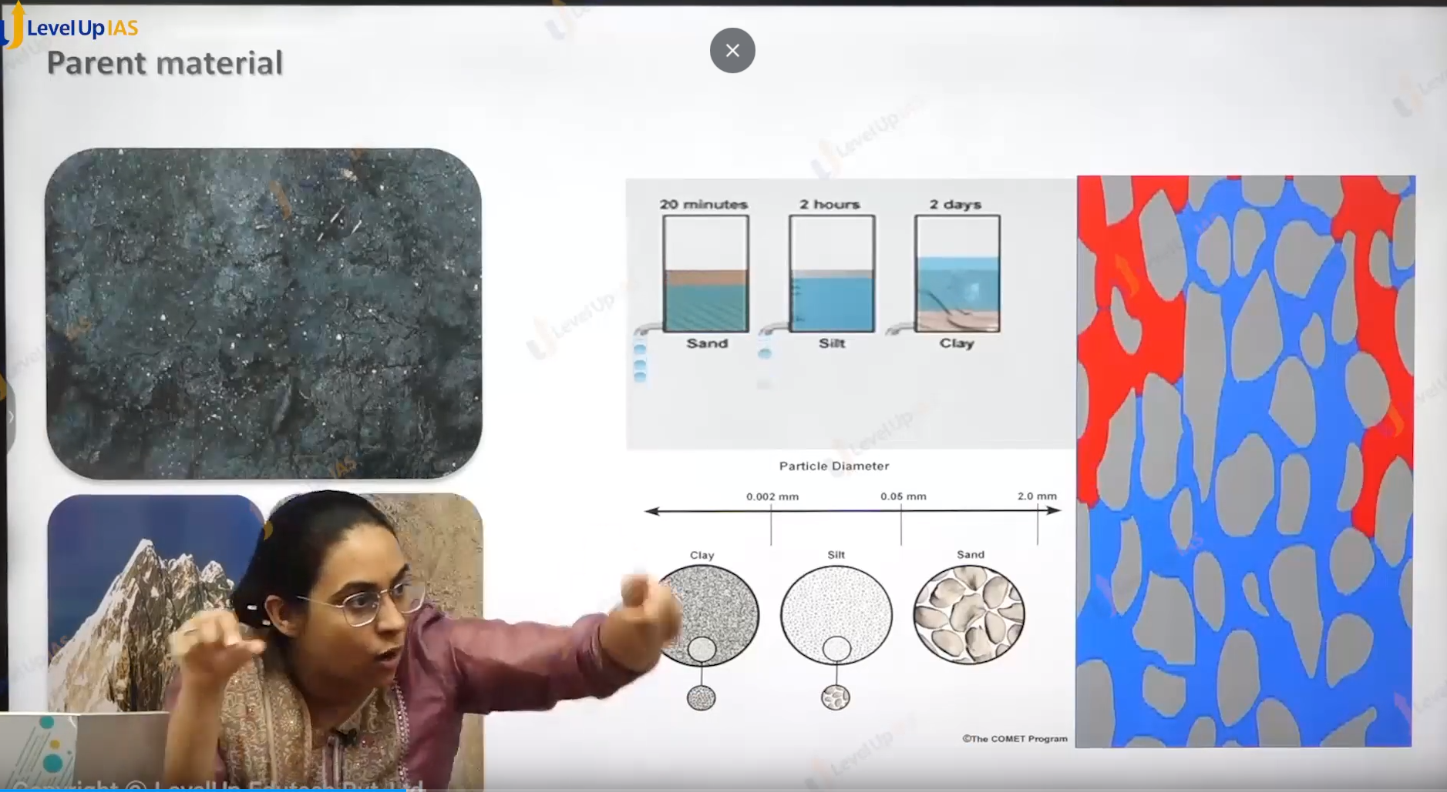

Parent rock :

1. Parent rock determine the color of soil. The nutrient, the texture of soil , the permiablity of porosity of soil.
2. Color :
   1. Basalt give black color soil.
   2. Granite gives red color soil.
   3. Limestone goves white color soil.
3. Nutrients:a
   1. Granite give iron rich soil.
   2. Basalt gives soil which is rich in feromagnite siilliecate.
4. Perant rock determines the texture of
   1. Soft rock ex basalt gives fine texture soil which makes soil porous. Ex black cotton soil.
   2. Hard rock gives core texture soil. Which makes the soil permeable. Red soil.

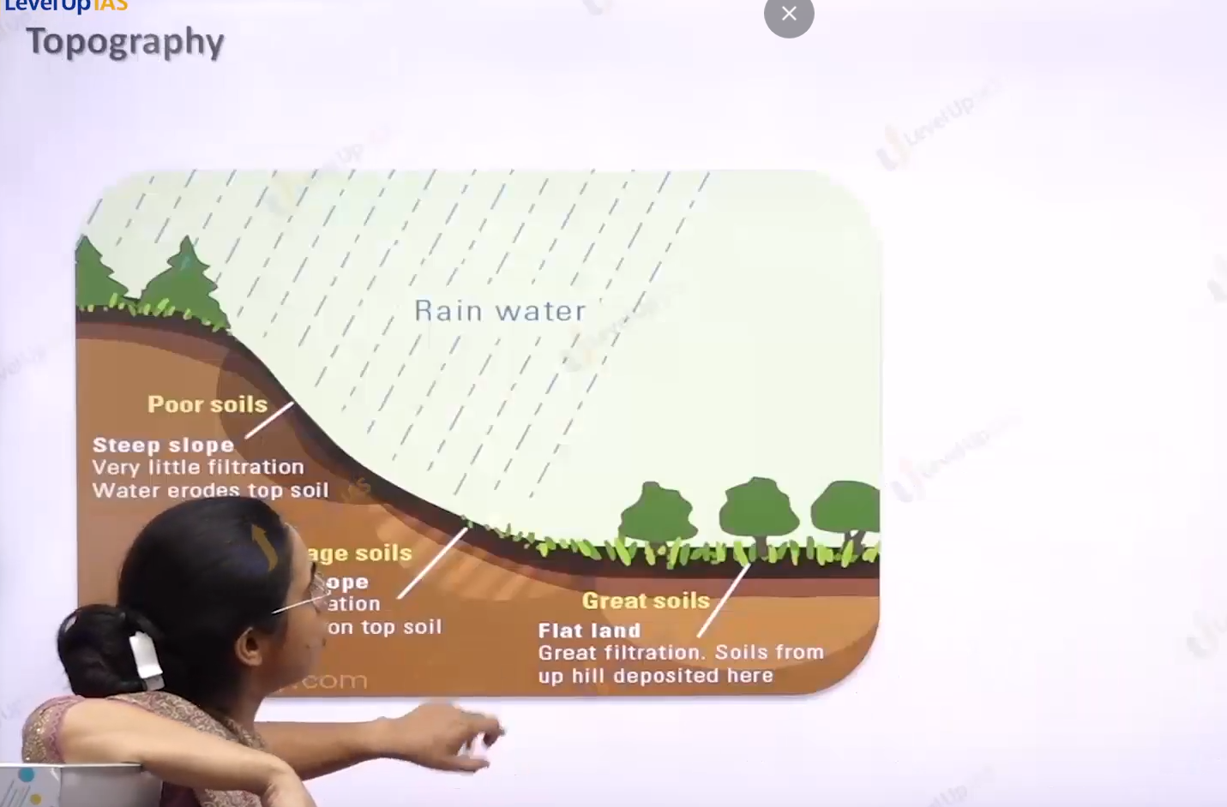

1. Topography affects the thickness of soil steep slope less thickness of soil gentle slope.

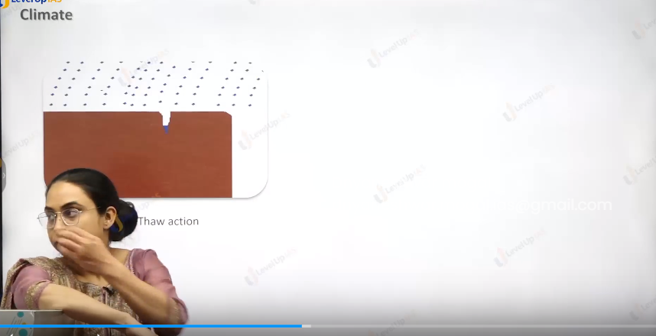

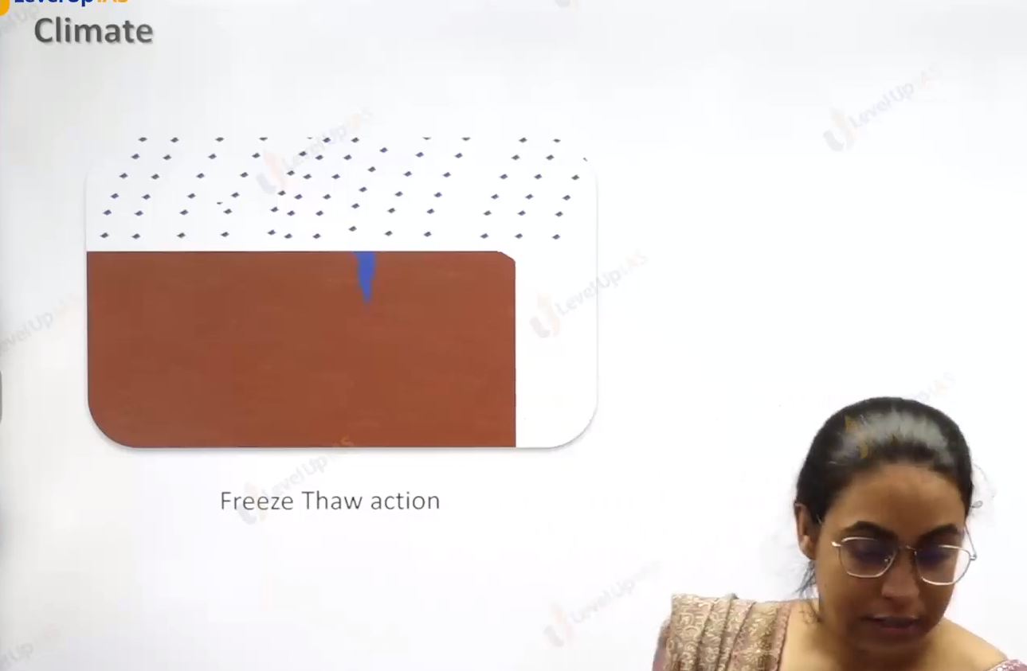

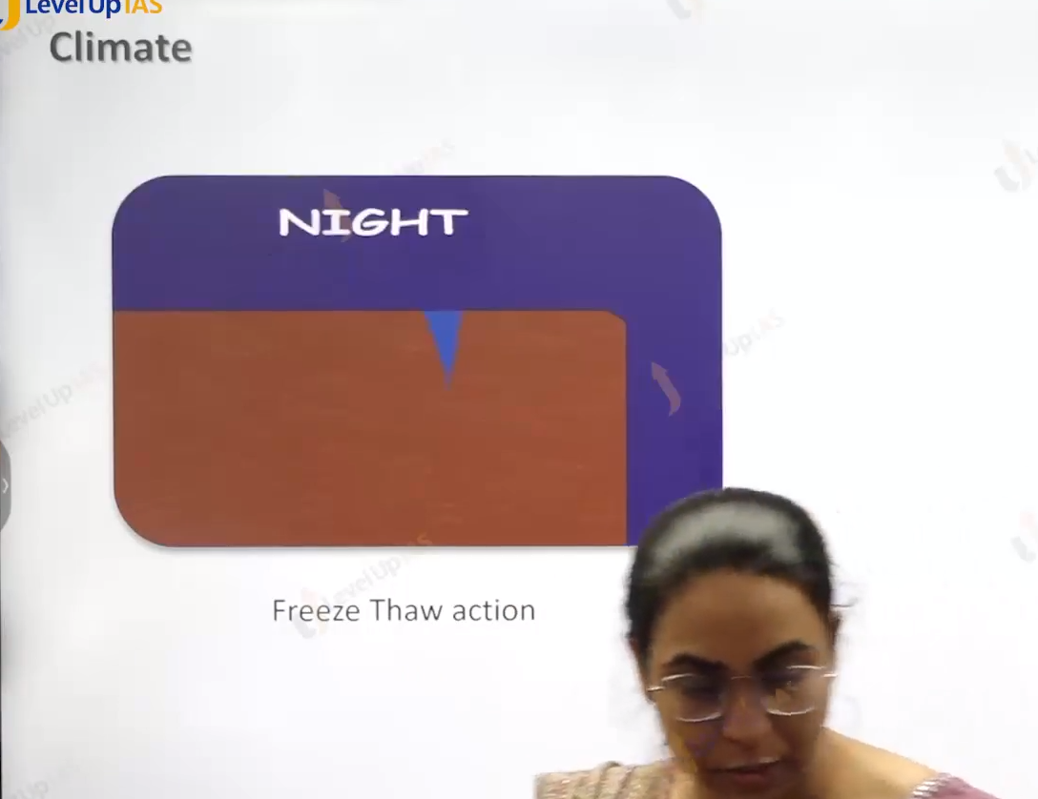

  
Climate:

1. Climate determines the process like type of weathering dry climate facilitate the physical weathering whereas moist climate facilitates chemical weathering. Climate also determines whether the process of leaching takes place or process the capillary action takes places.
2. Dry climate facilitates the capillary action whereas humid climate facilitates the leaching
3. Leaching refers to a process where the nutrients are dissolved in the rainwater, and it moves top layer to the lower layers.
4. Leaching very slow process and it generally seen in the area that has more rainfall than evaporations.

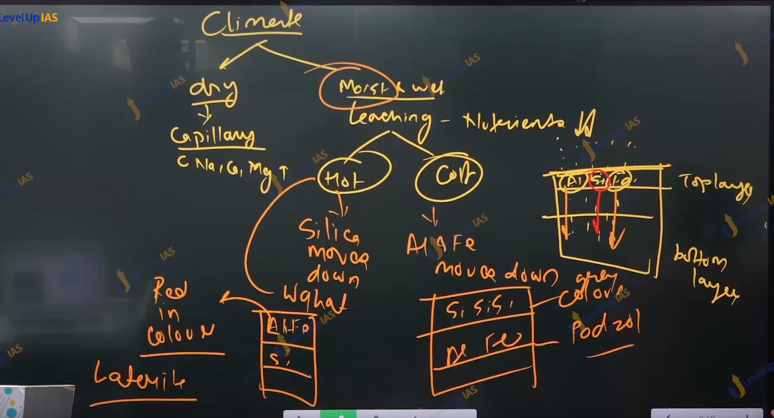

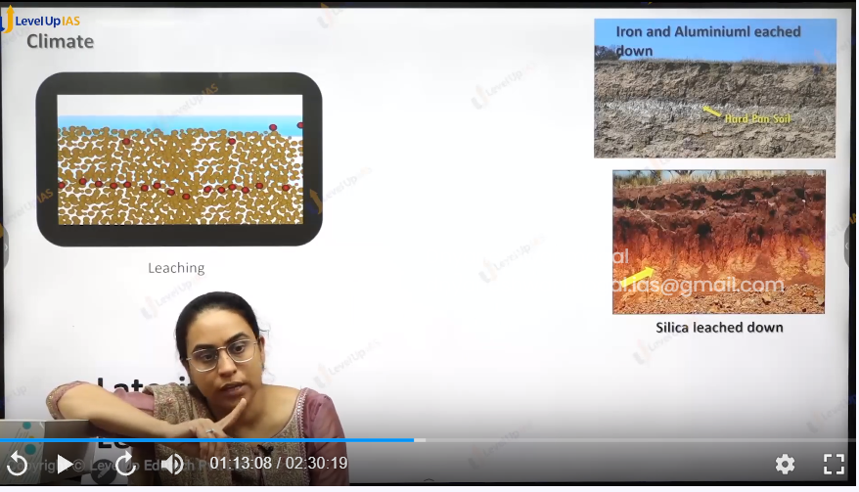

Leaching :

1. Leaching can be of 2 type that is Lateralization and podzolization.

Lateralization:

1. In the region of hot and most conditions silica is leach is down and iron and aluminum oxides are seen in the top layers.
2. Which makes the soil appears red in color such soil is called as lateralized in soil in places that has alternate wet and dry conditions. Such as it seen in western ghat and eastern ghat.
3. Laterization soil is used for brick making it also support of forestry and some type of plantation of agricultural cultivation of rubber coffee tea.
4. Unlike the red soil which is red in color due to parent material lateraled soil is red in color due to the process of leaching.

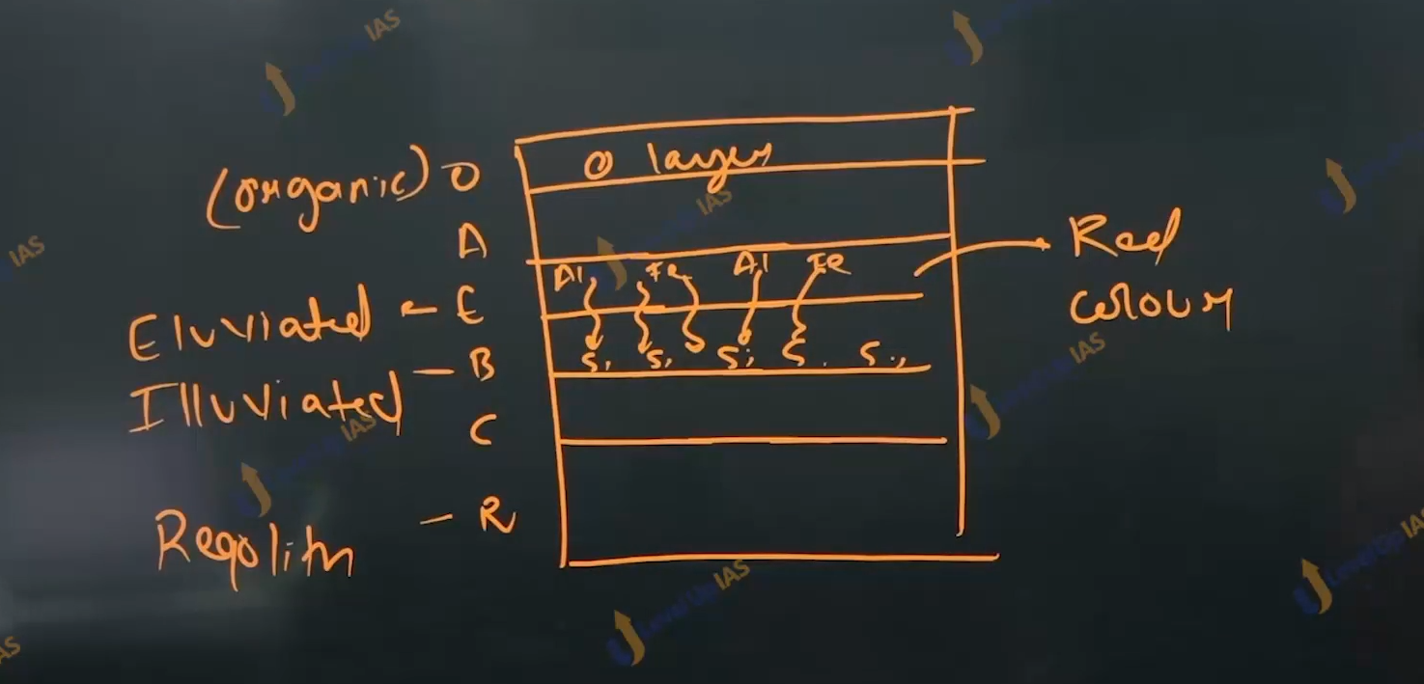

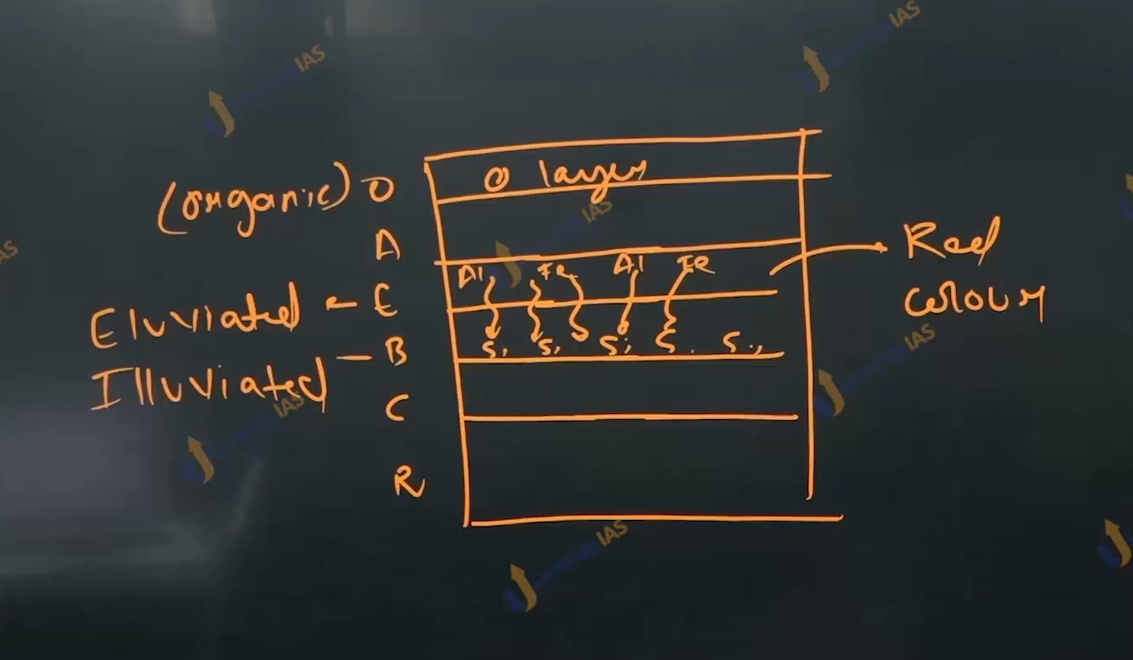

Podzolization:

1. In the area of cold and humid conditions, iron and aluminum is leached whereas silica remains int eh top layer this makes the soil. Gray in color. It is seen in India in the top reaches of Himalayas
2. Podzolic is generally seen in temperate regions.

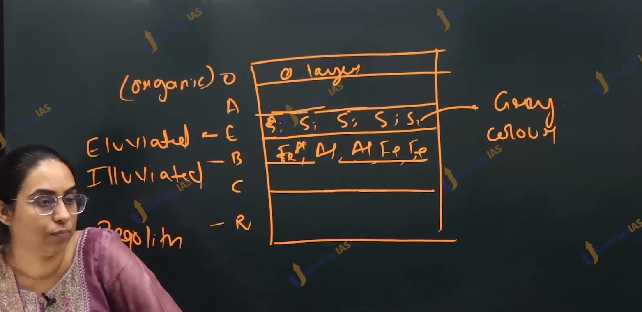

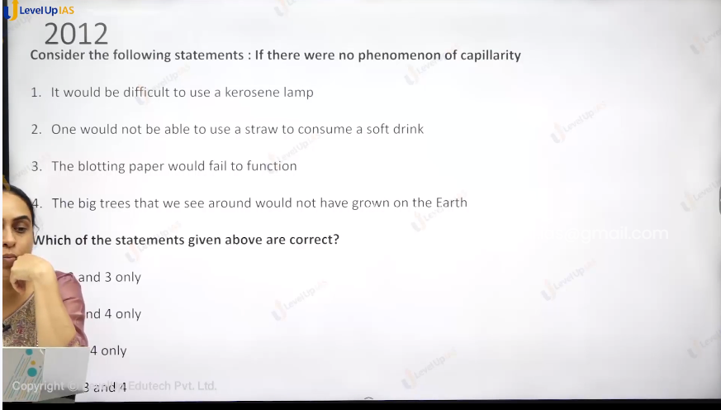

Options are not visible.

Option is c 3 and 4

Option d is all of above.



Ans is b.

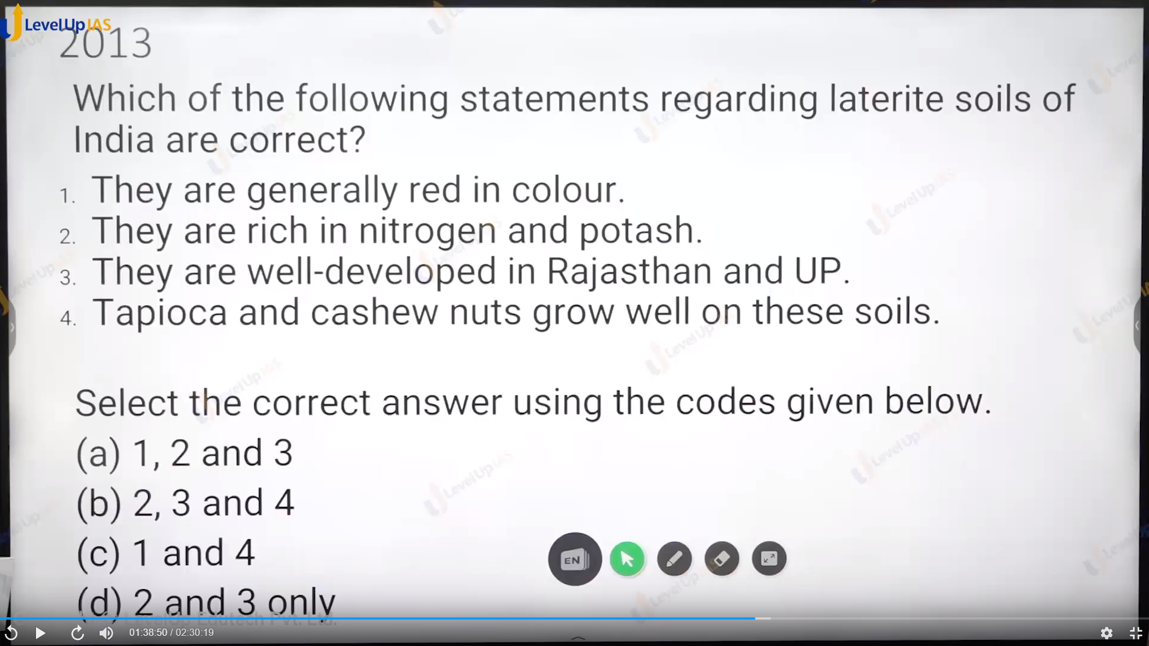

Ans is c.

r 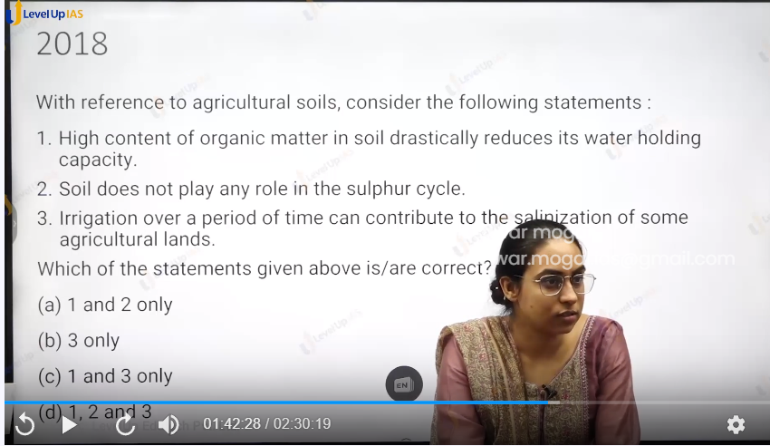

ans id b 3 only

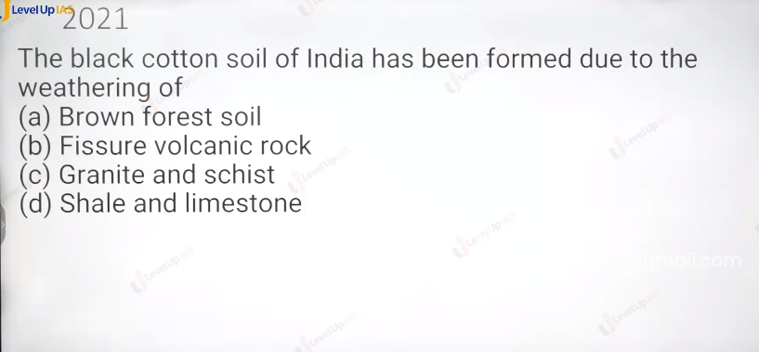

Ans is b : granite red soil.

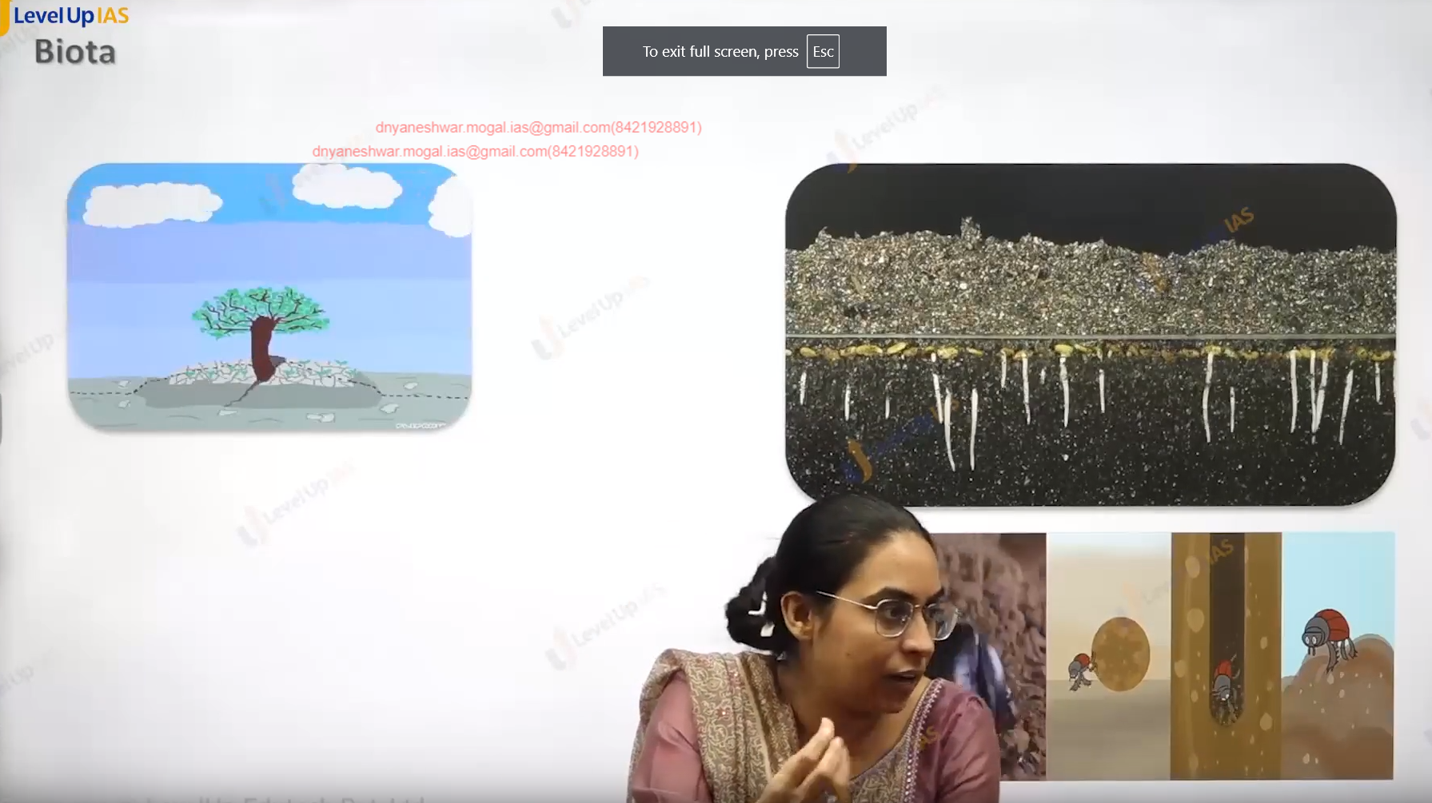

Biota:

1. The tree breaks the rock and leads to weathering. Earthworm can turn the soil. And helps in bio terbations.
2. The accumulation of humas because the decomposition of leaves steam shrubs etc.
3. Whether humas keep accumulating or would be decomposed depends on bacterial acidity. In the region high temperatures high bacterial activity leads to disintegration of humas containing to less fertility of soil.
4. Whereas in the temperate region more acclamation of humas soil is very fertile. Ex. the soil in temperate grasslands. Steeps black sea.

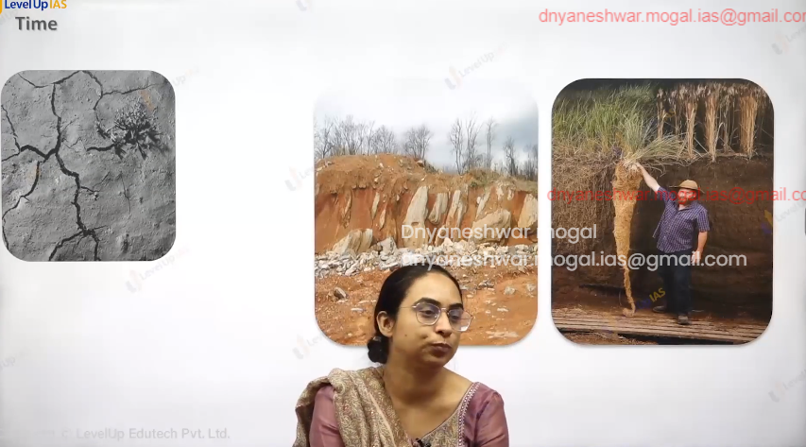

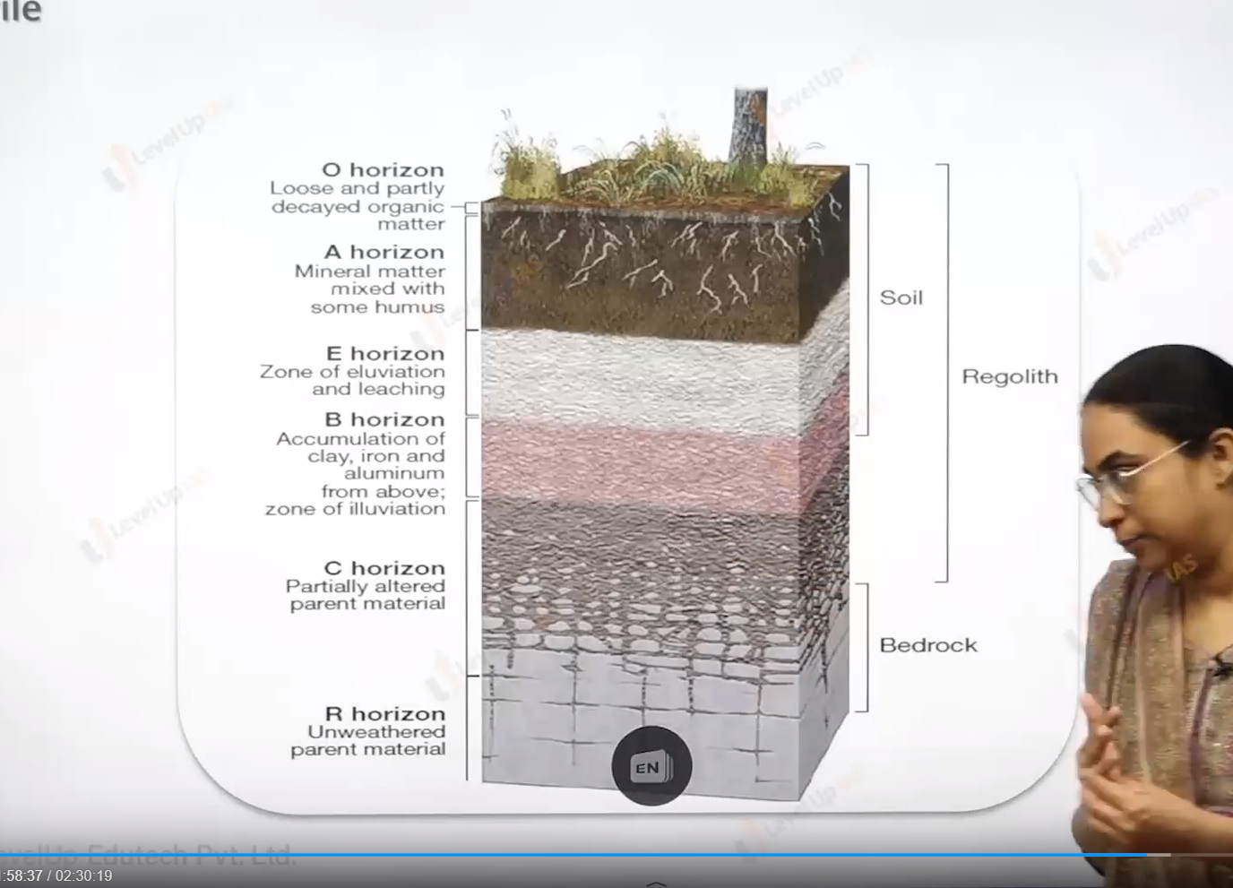



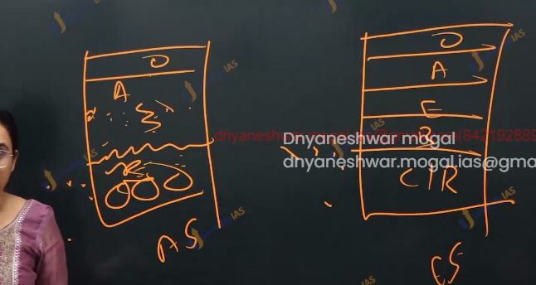

Role of Time

1. Times determines whether the soil has developed many horizons or not. Time determines the mutuality of soil.
2. Mature soil Has fully developed horizontally. Ex. Equatorial soil. Whereas young soil does not have fully developed horizons.

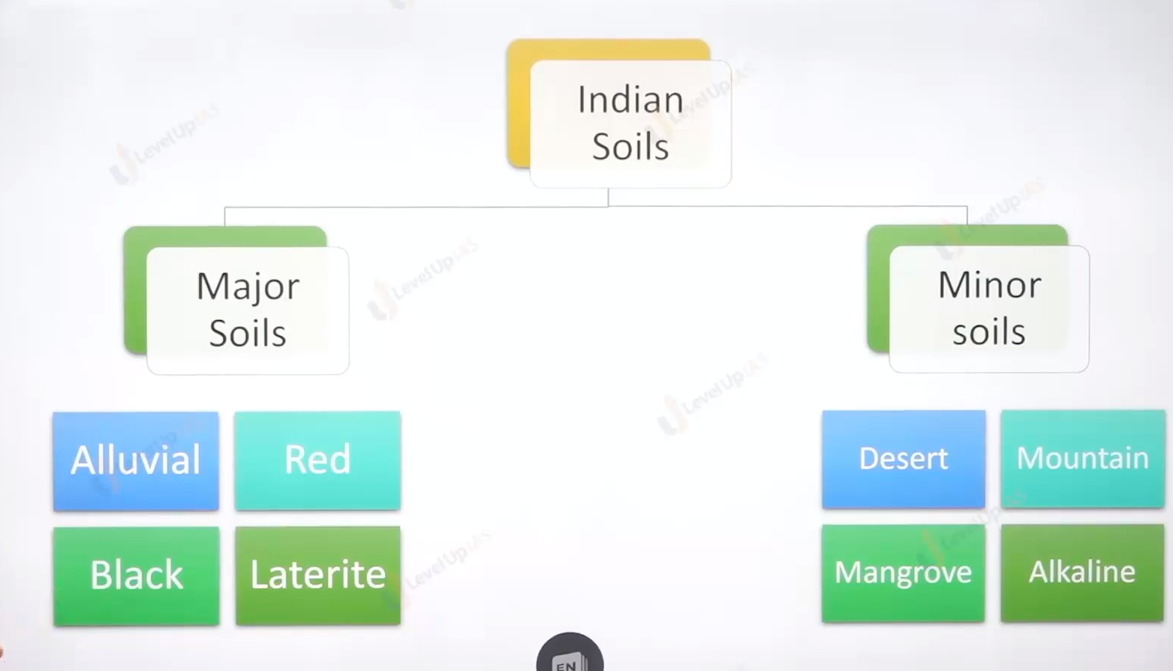

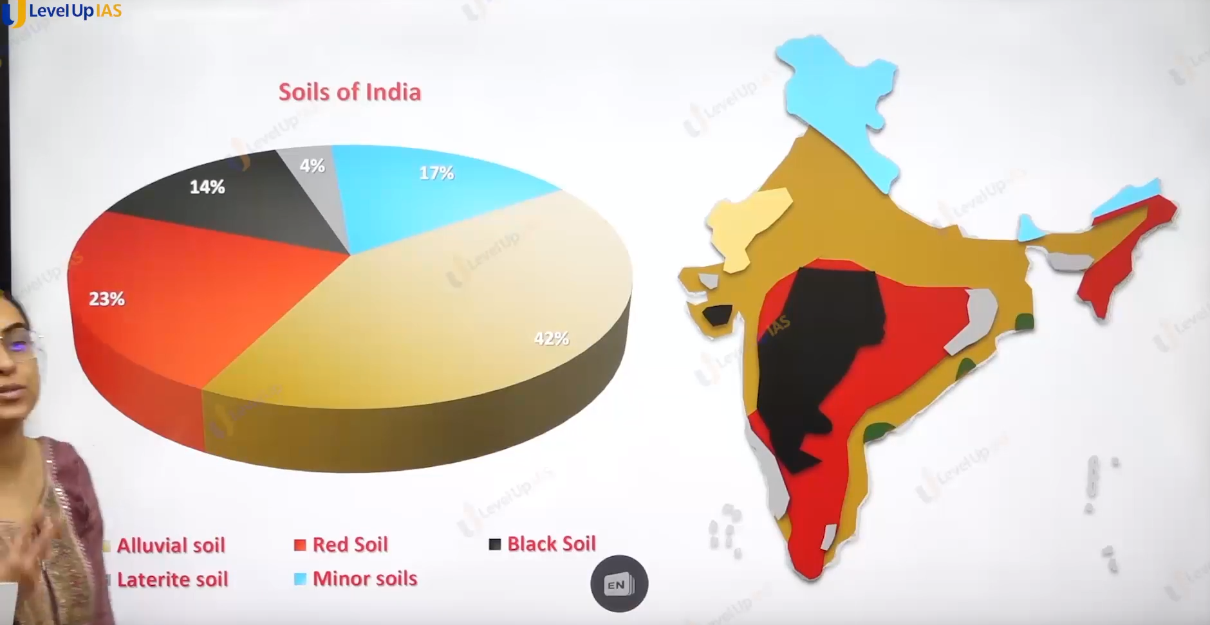

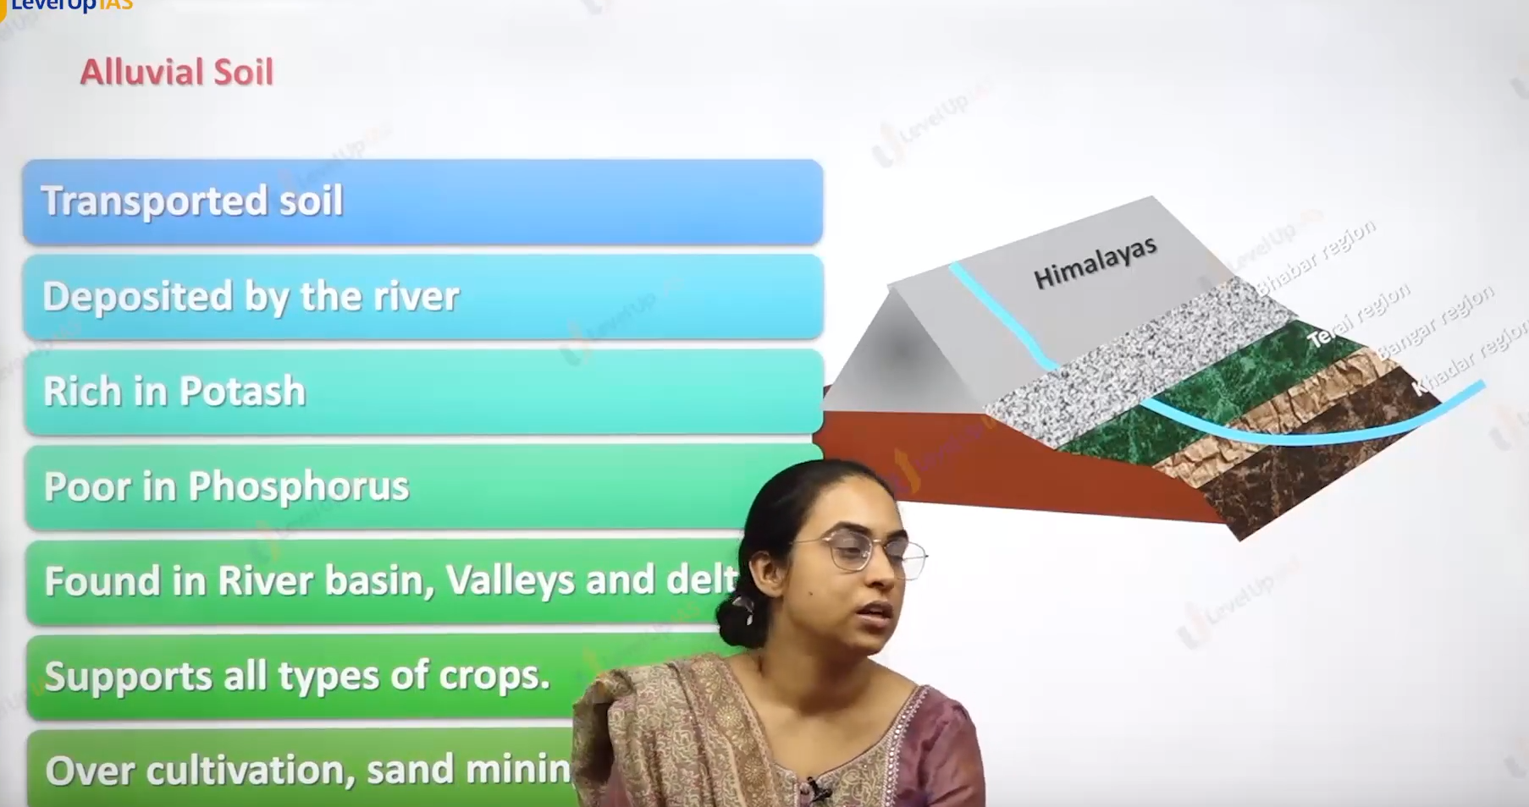

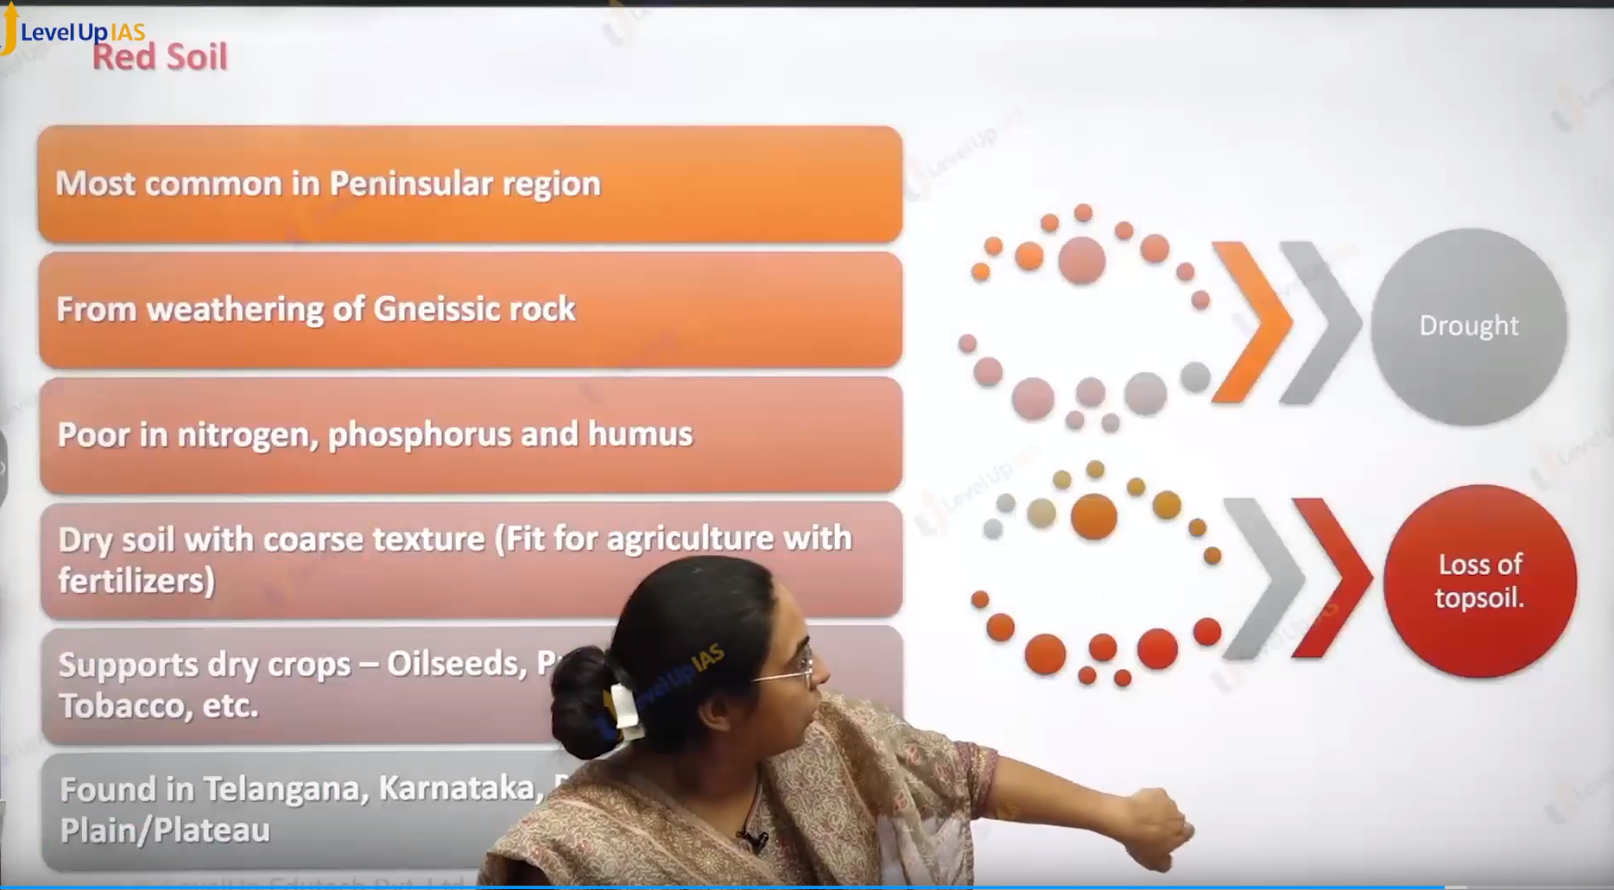

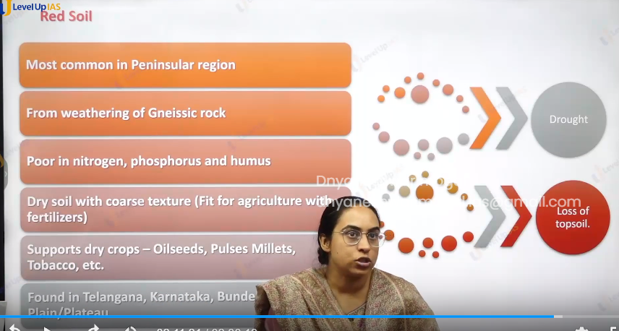

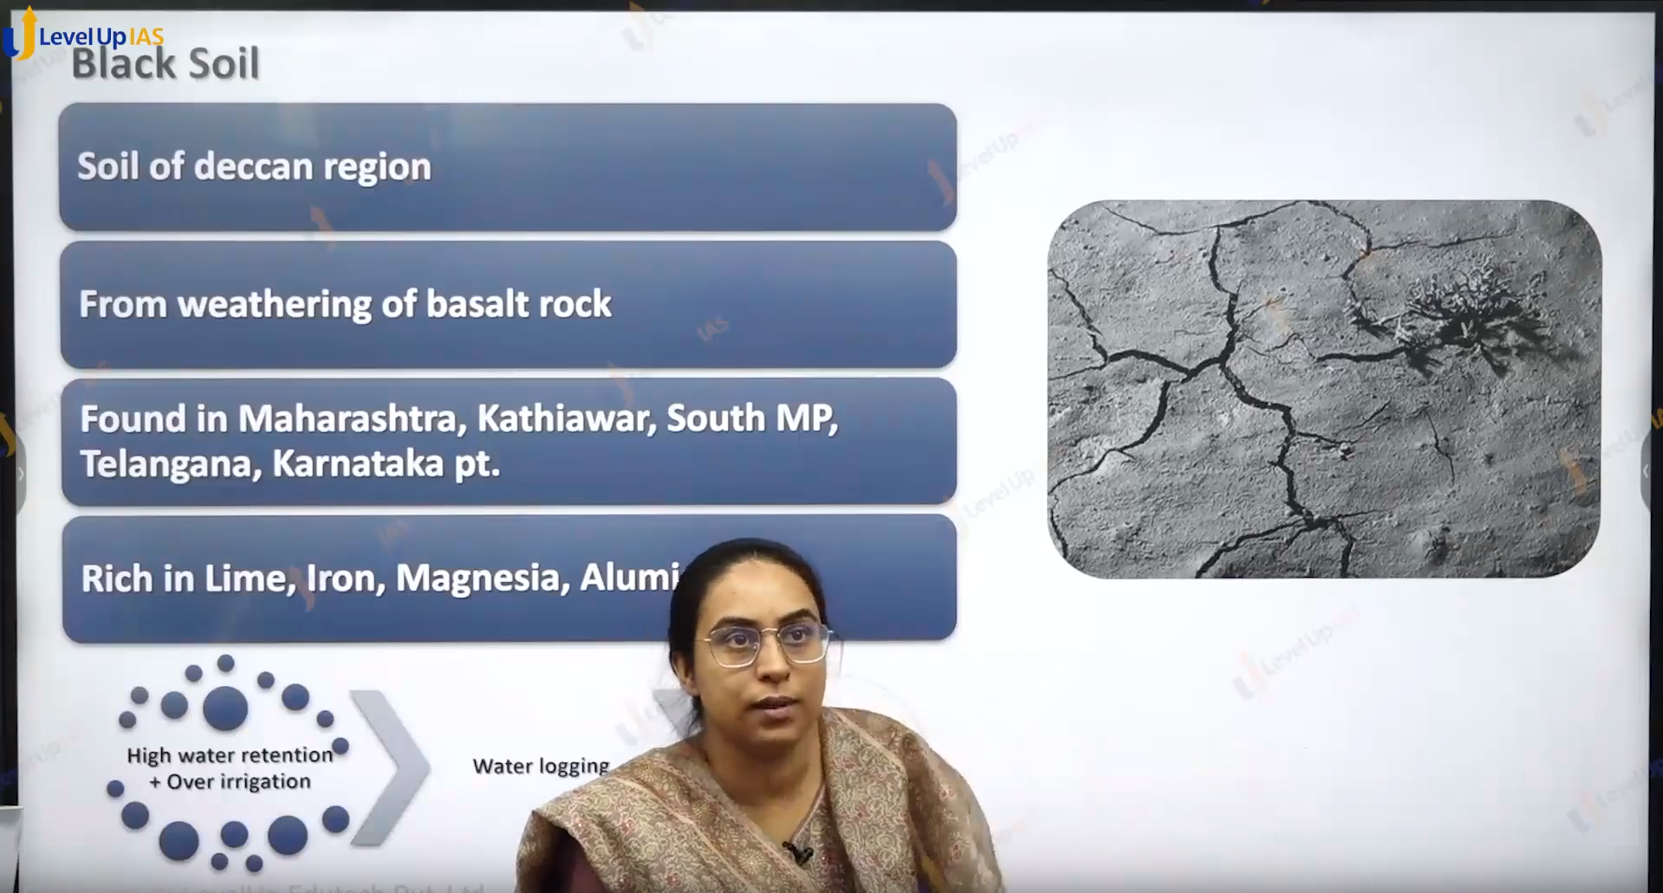

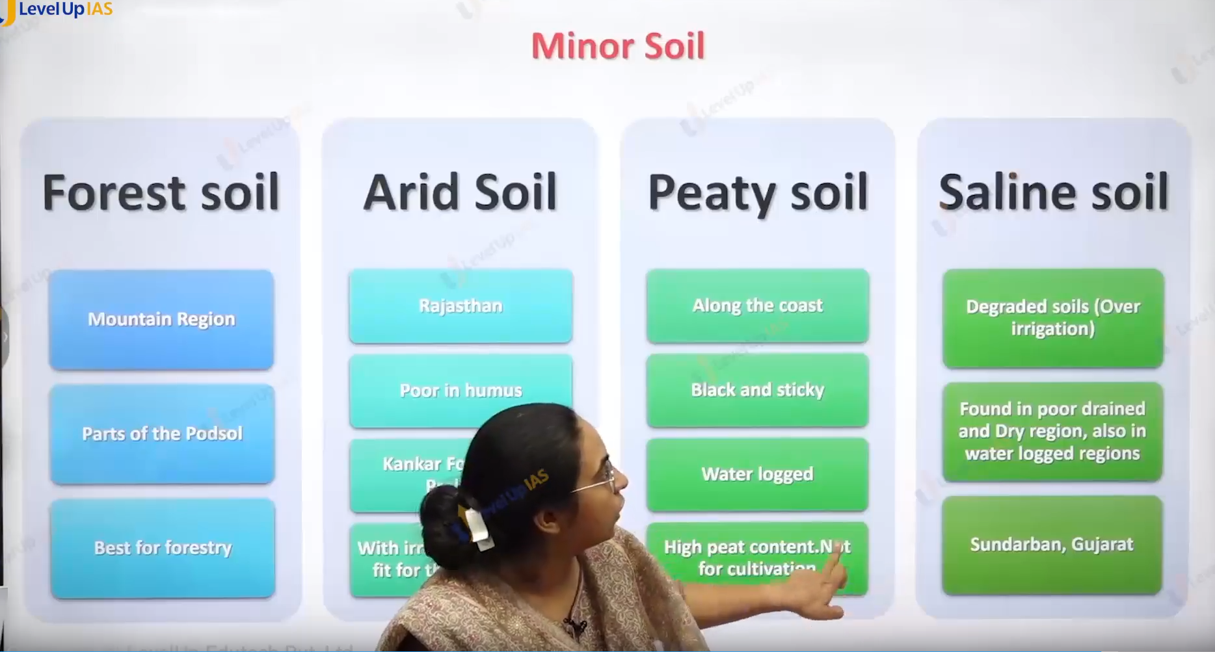

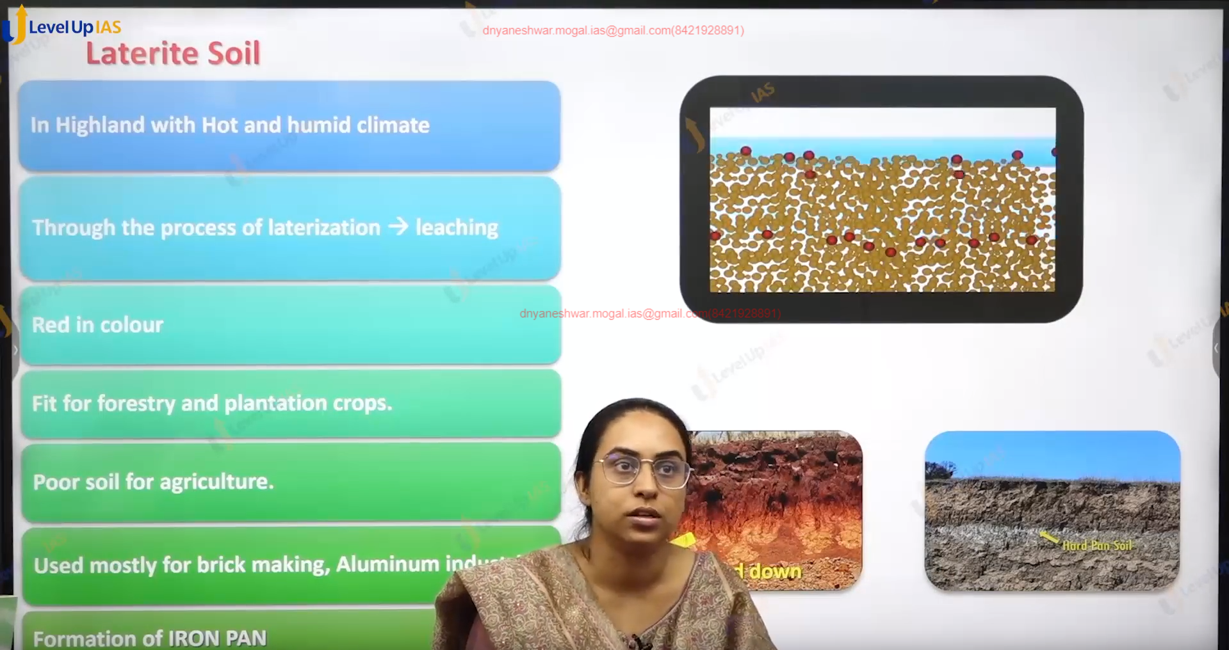

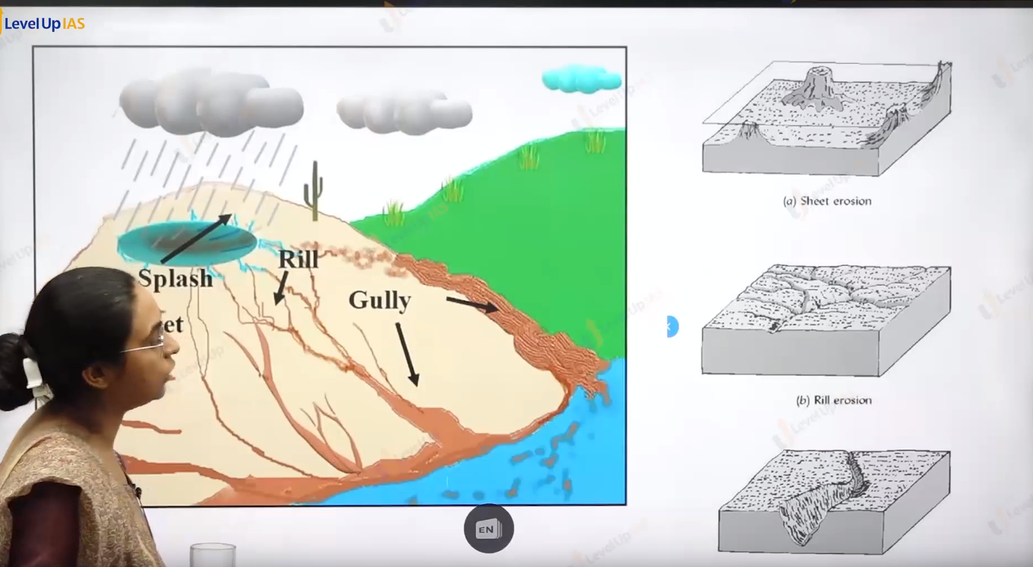

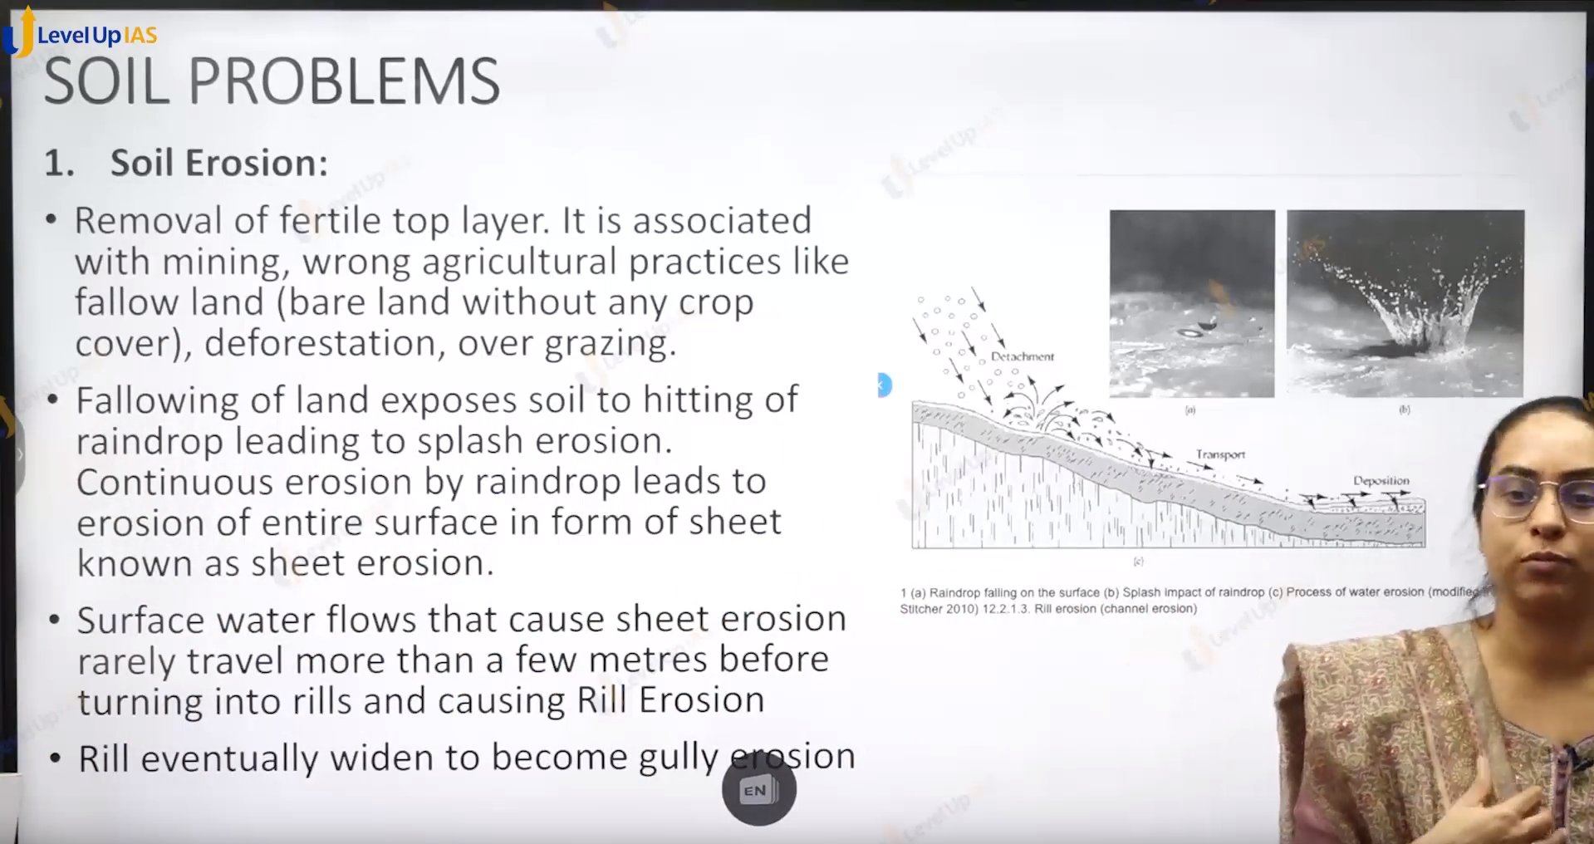

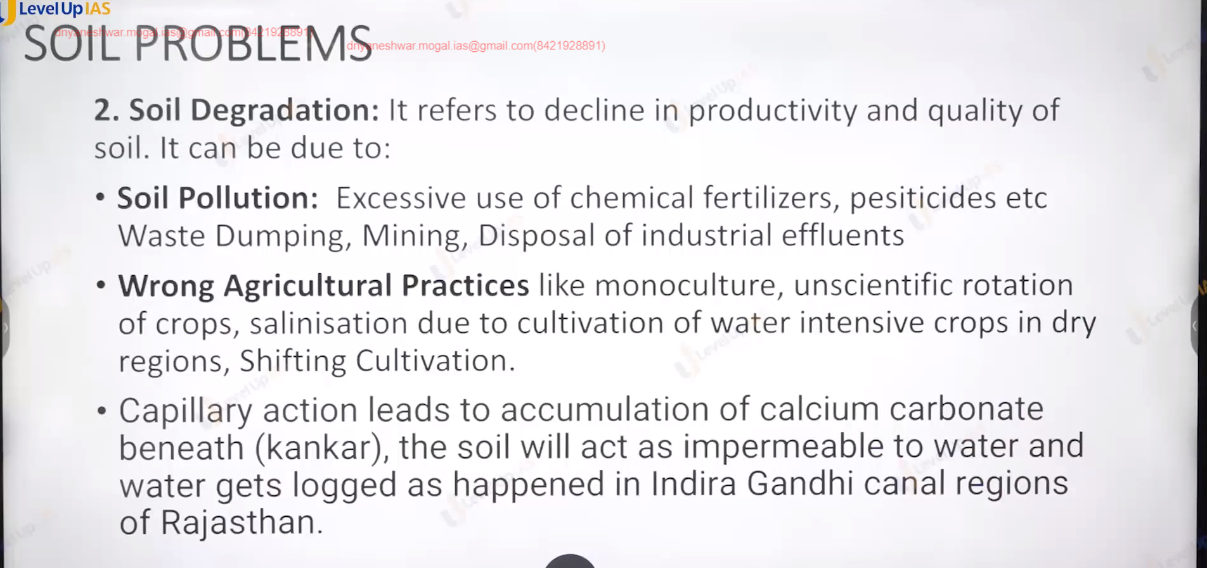

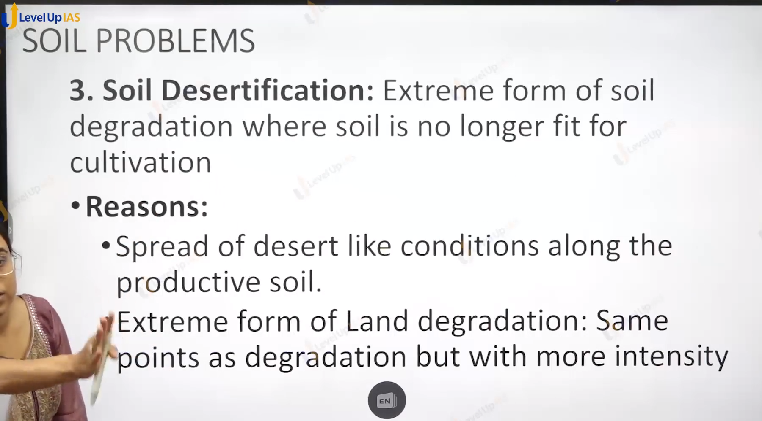

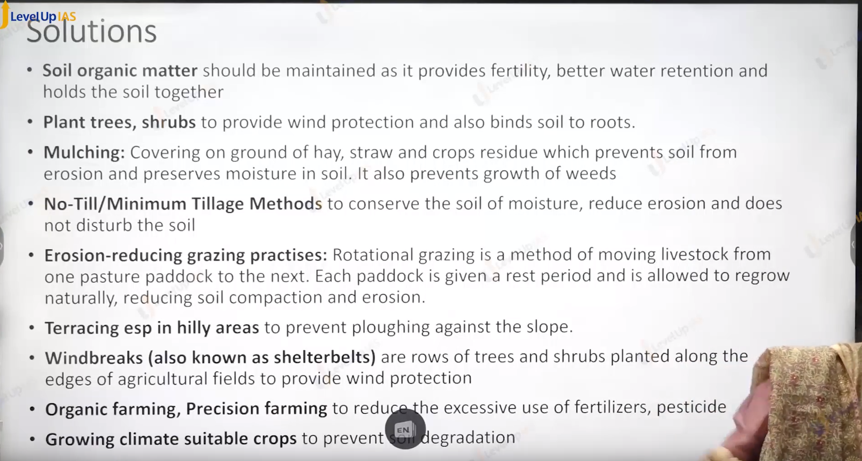



Ans c .

